Gene regulatory divergence underlies tissue-specific and sex-specific misexpression in hybrids of C. remanei and C. latens nematodes

Athmaja Viswanath ¹, Daniel D. Fusca ¹, John A. Calarco ², and Asher D. Cutter ¹*
¹Department of Ecology & Evolutionary Biology
²Department of Cell & Systems Biology
University of Toronto, Toronto, Ontario, M5S3B2 Canada

*Author for correspondence: asher.cutter@utoronto.ca

Abstract
Gene regulatory divergence has emerged as a key feature in speciation, influencing gene expression differences within and between species. Transcriptional regulation, mediated by cis- and trans-acting factors, modulates developmental processes and maintains species-specific distinctions in gene expression. Within interspecies hybrids, negative interactions between divergent cis- and trans-acting factors can lead to gene misregulation and contribute to hybrid dysfunction at the organismal level. Such gene regulatory mismatch can specifically impact sex-biased and tissue-biased gene regulatory networks due to unique selective pressures experienced by such genes. Despite extensive research on regulatory divergence and hybrid misexpression, establishing the relationship between gene misregulation and hybrid incompatibility remains difficult. Importantly, however, comparing hybrids from reciprocal crosses with asymmetric hybrid incompatibility can reveal gene regulatory patterns associated with cross-specific dysfunction. We investigated the role of regulatory divergence in asymmetric hybrid incompatibility between two sister species of nematodes - C. remanei and C. latens. Despite severe hybrid male sterility, hybrid males showed less misexpression of sex-biased genes than hybrid females, in both reciprocal crosses, suggesting that the outputs of male-biased gene regulatory networks are more vulnerable to disruptions than female-biased genetic networks. Additionally, we found more genes to be associated with cis divergence than trans, supporting the notion that cis divergence plays a larger role in gene expression differences between species. Moreover, we find extensive X-linked, male-specific cis-trans compensatory divergence, indicating distinct molecular evolutionary outcomes of stabilizing selection on regulatory controls in males and females. Through this work, we generated the most comprehensive transcriptomic dataset for C. remanei and C. latens to our knowledge, uncovered insights on asymmetric misexpression and identified candidate genes contributing to reproductive isolation.

Introduction
Reproductive isolation is an essential feature of speciation that prevents gene flow between diverging populations and maintains species boundaries. Unfit offspring between species are a direct consequence of genetically intrinsic postzygotic barriers, which arise due to negative interactions between genetic factors from different species within the hybrid genome. Such negative epistatic genetic interactions are commonly referred to as Bateson Dobzhansky Muller incompatibilities (BDMIs) (Bateson 1909; Dobzhansky 1937; Muller 1942). These incompatibilities hinder the normal progression of the hybrid’s developmental processes, ultimately resulting in hybrid dysfunction that can cause extreme phenotypes such as inviability and sterility (Coyne & Allen Orr, 1998; Orr, 1996) as well as more subtle defects such as delayed development (Bomblies et al., 2007; Matute & Coyne, 2010) and behavioral abnormalities (Rice & McQuillan, 2018; Turissini et al., 2017). A prominent pattern observed in F1 interspecies hybrids, known as Haldane's Rule, is the greater susceptibility of the heterogametic sex to hybrid dysfunction (Haldane, 1922) and is supported by extensive evidence in diverse taxonomic groups (Cowell, 2022; Coyne & Orr, 2004; Cutter, 2018; Delph & Demuth, 2016; Schluter & Rieseberg, 2022). Numerous hypotheses have been put forth to account for the underlying mechanism for such sexually asymmetric hybrid dysfunction, including the dominance theory, which posits that sterility is attributable to X- or Z-linked recessive genes, the faster male theory, which suggests that dysfunction may arise from the rapid divergence of male-biased genes, and the faster-X theory, which proposes that rapid divergence of X-linked loci may result in X-linked incompatibilities, among other (Cowell, 2022; Delph & Demuth, 2016; Presgraves, 2010; Turelli, 1998). Another asymmetry pertaining to interspecies hybrids is Darwin's corollary to Haldane's rule (Turelli & Moyle, 2007) in which the severity of hybrid dysfunction differs by the specific direction of the cross (i.e. maternal species), indicating the influence of uniparentally inherited factors that contribute to unidirectional incompatibilities, such as X-linked and mitochondrial genes, and epigenetic factors (Turelli & Moyle, 2007). Despite the considerable efforts made in studying the genetic basis of post-zygotic reproductive isolation for almost a century, and the aforementioned broad trends, a consensus regarding the relative importance of specific causal mechanisms across different taxa has not yet been reached.
Divergence in the mechanisms regulating gene expression has been shown to play an important role in maintaining differences between species and variations within populations (Mack & Nachman, 2017; Runemark et al., 2024; Signor & Nuzhdin, 2018; Wittkopp et al., 2004). Gene regulatory mechanisms can govern the quantity, location, functioning, and interactions of genes, thus dictating crucial developmental processes in organisms and upholding species-specific distinctions in expression (Mack & Nachman, 2017; Signor & Nuzhdin, 2018). Gene regulation at the transcriptional level relies on the interplay between cis-acting elements (e.g., promoter or enhancer sequences) and trans-acting factors (e.g., transcription factors), with some trans-acting factors capable of operating post-transcriptionally (e.g., miRNAs). cis-regulatory elements are commonly located upstream of genes and primarily impact gene expression in a localized manner, whereas trans-acting factors arise from other regions of the genome and typically can exert control over the regulation of multiple target genes (Mack & Nachman, 2017). In F1 interspecies hybrids, interactions between divergent cis- and trans-acting factors from different parental species can lead to gene misregulation, impacting developmental pathways and resulting in hybrid incompatibilities like inviability and sterility (Mack & Nachman, 2017). The relative influence of trans-regulatory mutations on gene expression is expected to be a greater source of variation within a species, potentially due to their increased pleiotropic effects as they impact multiple targets to get weeded out or compensated over time (Metzger et al., 2017; Signor & Nuzhdin, 2018). Changes in cis-regulatory elements are expected to play a comparable role to trans-acting factors (Coolon et al., 2015; Gomes & Civetta, 2015; Guerrero et al., 2016; McManus et al., 2010; Shi et al., 2012), or a stronger role (Mack et al., 2016; Wittkopp & Kalay, 2012), in creating gene expression differences between species (Carroll, 2005; Hill et al., 2021; Stern & Orgogozo, 2009). Moreover, cis- and trans-acting factors can co-evolve to compensate for previous evolutionary changes and maintain profiles of gene expression at similar phenotypic levels between species. Such coevolved differences, however, can break down in F1 hybrids and manifest as hybrid misexpression due to dysfunctional cis-by-trans interactions (Mack & Nachman, 2017). These compensatory changes underlying the expression phenotype are expected to evolve under stabilizing selection and often result in developmental system drift, a phenomenon whereby gene expression phenotype is maintained between species despite molecular evolution of gene regulatory sequences (Cutter & Bundus, 2020; Mack & Nachman, 2017; Schiffman & Ralph, 2022; Signor & Nuzhdin, 2018; True & Haag, 2001). Divergence in such gene regulatory mechanisms plays a key role in reproductive isolation with evidence across different taxonomic groups, although debate continues about the relative contributions of alternative molecular mechanisms (Guerrero et al., 2016; X. C. Li & Fay, 2017; Mack et al., 2016; Mack & Nachman, 2017; McManus et al., 2010; Meiklejohn et al., 2014; Sánchez-Ramírez et al., 2021).
Gene regulatory mechanisms also modulate tissue-biased and sex-biased gene expression of the same genes when in distinct cell types or when in male and female individuals (Ellegren & Parsch, 2007). Genes with such context-dependent expression can experience distinct selective pressures, and might contribute disproportionately to species differences due to their potentially faster evolution than genes with non-differential expression (Assis et al., 2012; Harrison et al., 2015; Parisi et al., 2004; Viswanath et al., 2025). Misregulation of sex-biased genes, in particular, can manifest as dysfunction in sex-specific developmental programs in hybrids and can have implications for sex-specific hybrid incompatibility and Haldane’s rule (Assis et al., 2012; Cutter, 2023a; Gomes & Civetta, 2015; Ranz et al., 2004; Sánchez-Ramírez et al., 2021). Although divergence in the mechanisms governing the regulation of sex-biased genes can contribute to hybrid sterility, the complex relationship between the selective forces that drive sex-biased expression and their impact on the process of speciation is still not clearly understood (Ellegren & Parsch, 2007; Gomes & Civetta, 2015; Harrison et al., 2015; Meiklejohn et al., 2014; Servedio & Boughman, 2017; Servedio & Bürger, 2014).
Misexpression linked to hybrid incompatibility, specifically hybrid sterility, can be studied by comparing gene misregulation between sterile and fertile hybrids (Civetta, 2016). Despite the significant amount of research on regulatory divergence, it has been difficult to establish a direct connection between hybrid sterility and gene misregulation and this can be primarily attributed to limited cases of direct comparison between sterile and fertile hybrids (Brekke et al., 2021; Gomes & Civetta, 2014, 2015; Good et al., 2010; Larson et al., 2017; Mack et al., 2016). Importantly, however, hybrids from reciprocal crosses that exhibit asymmetry in hybrid male sterility, demonstrating Darwin's corollary to Haldane's rule, can provide significant insights into the molecular mechanisms that cause misexpression and ultimately are responsible for hybrid sterility. This approach allows for a direct comparison of nearly identical F1 hybrid genomes that, for males, only differ in the X-chromosome (Civetta, 2016). While this approach fails to distinguish between sterility causing genes and the genes they impact, it helps to narrow a subset of candidate genes likely to be associated with hybrid sterility. Although previous studies have employed hybrids generated from reciprocal crosses to investigate the factors contributing to asymmetric hybrid sterility, our understanding of the underlying mechanisms behind these asymmetric patterns remains limited (Brekke et al., 2021; Gomes & Civetta, 2015; Larson et al., 2017; Mack et al., 2016). We aimed to build on prior studies to investigate the role of regulatory divergence and gene misregulation underlying asymmetric hybrid sterility by comparing gene expression between sterile and fertile hybrids of two Caenorhabditis nematodes: Caenorhabditis remanei and C. latens (Bundus et al., 2018; Dey et al., 2012, 2014).
C. remanei and C. latens are sister species of nematodes that diverged ~5 MYA (Dey et al., 2012; Félix et al., 2014). The nematodes are diploid and have five autosomal chromosomes, but their X-chromosomes differ between sexes: males have one X-chromosome whereas females have two X-chromosomes. Furthermore, the regulation of X-linked gene expression in females involves dosage compensation achieved by reducing the expression of both X-chromosomes in females (Meyer, 2022). Hybrids can be formed between these sister species in both directions of the cross, and Haldane’s rule applies, with hybrid males showing greater hybrid sterility and inviability compared to hybrid females (Dey et al., 2014). Additionally, hybrids resulting from reciprocal crosses exhibit an asymmetry in hybrid incompatibility (Darwin’s corollary to Haldane’s rule) (Turelli & Moyle, 2007) with hybrids formed with C. remanei as the maternal parent displaying higher hybrid male sterility and inviability than hybrids derived from C. latens mothers (Bundus et al., 2018; Dey et al., 2012, 2014). Previous studies on this system have also indicated that the genetic basis for hybrid male sterility is likely simpler than hybrid inviability, involving negative gene interactions between the X-chromosome and autosome(s) (Bundus et al., 2018). Furthermore, previous research also supports the notion that divergence in sex-biased gene regulation could be a contributing factor to the species-level differences in gene expression observed between C. remanei and C. latens (Viswanath et al., 2025). We investigated the role of gene regulatory divergence in asymmetric post-zygotic reproductive isolation between C. remanei and C. latens by generating a transcriptomic dataset spanning two species (C. remanei and C. latens), two sexes (males and females), two tissues (gonad and soma) and hybrids from both reciprocal cross directions. To complement the inaccessibility of H1 male gonad tissue in these animals, due to defects in gonad morphogenesis that prevented analysis of this treatment, we also analyzed transcriptomic data from whole males of C. remanei, C. latens and hybrid males for both reciprocal crosses. This collection of samples enabled us to address the effects of tissue type and sex, as well as tissue allometric scaling that can make it challenging to study hybrid misexpression (Assis et al., 2012; Harrison et al., 2015). With this study, we generated the most comprehensive transcriptomic dataset for C. remanei and C. latens to date that incorporates key features to answer open questions about the evolution of asymmetric misexpression between hybrid cross directions, the role of sex differences in gene regulatory evolution and in sex-biased hybrid misexpression, and whether different tissues reveal tissue-specific species differences in the mechanisms of gene regulatory control.

Methods

Nematode dissection and RNA isolation
We expanded the dataset used in Viswanath et al., 2025 to include transcriptomic data from hybrids in addition to wildtype samples. We followed the methods outlined in Viswanath et al., 2025 to isolate gonad and soma from C. remanei x C. latens hybrids from both directions of the cross. Briefly, we cultured three replicate populations of C. remanei (P1), C. latens (P2) and F1 hybrids from each reciprocal cross direction (H1 with maternal C. remanei & H2 with maternal C. latens). We extracted total RNA from ~400 animals per replicate, including gonad and somatic tissue from male and female adults of wildtype species and hybrids. The F1 male hybrids with C. remanei as the maternal parent (H1) had severe gonad defects preventing isolation of gonad tissue for these males, so we additionally collected RNA from whole male worms for C. remanei, C. latens and hybrid males from reciprocal crosses (H1 & H2) to directly compare expression across the different treatments. All the hybrid samples along with those analyzed in Viswanath et al., 2025 were processed in parallel, being stored in Tri-reagent at -80C for ~48-72 hours, after which RNA was isolated by Zymo RNA isolation kit (#R2051), treated with Turbo DNase (#AM2238) and RiboLock RNase Inhibitor (#EO0381) and further purified using Zymo RNA Clean and concentrator kit (#R1015) using the Manufacturer’s protocol making a total of 57 samples (3 replicates x 19 treatments), including the pure species samples described in (Viswanath et al., 2025) (Figure 1). These triplicate RNA samples per treatment underwent library preparation and sequencing (paired end, read length = 150bp, ~75 million reads/sample on NovaSeq S4 flowcell).

Sequencing and transcript analysis
All data processing steps were performed as described in (Viswanath et al., 2025). To summarise, the cDNA library preparation and next generation sequencing were performed by The Centre for Applied Genomics, The Hospital for Sick Children, Toronto, Canada. Custom (updated) annotations were used which were generated by CAGEF with gff files. RNA-seq data was quality trimmed with Trimmomatic (Bolger et al., 2014)(parameters: LEADING:3 TRAILING:3 SLIDINGWINDOW:4:15 MINLEN:36).

Read mapping and allele specific expression analysis
The quality verified reads were aligned to the C. remanei PX506 (Teterina et al., 2020) and C. latens PX534 v2 (Adams et al., 2023) reference genomes using default parameters of STAR (Dobin et al., 2013). The C. remanei and C. latens samples were mapped to their respective reference genomes while the hybrids were mapped to both C. remanei and C. latens reference genomes separately. We used CompMap, a python based competitive read mapping approach (Sánchez-Ramírez et al., 2021; Sánchez-Ramírez & Cutter, 2021) to quantify allele-specific expression (ASE) within each hybrid sample. We then used this quantified ASE to infer genes displaying different regulatory divergence. Following Sánchez-Ramírez et al. (2021), we used a linear model and a post-hoc Wald type test to test for significant trans effects (linearHypothesis from the CAR package). We then inferred regulatory divergence based on the statistical criteria defined by McManus et al. (2010) to identify genes displaying divergence due to cis-only, trans-only and joint cis-trans effects (Supplementary Figure S1). Genes that exhibited significant expression differences between parental species and hybrid alleles, but lacked significant trans effects, were identified as “cis-only” divergent. Genes with joint cis-trans effects were classified as having either synergistic cis + trans (enhancing) effects, where regulatory divergence of both cis- and trans-acting factors significantly increases expression of the same allele, or cis x trans (compensatory) effects, where cis-acting regulatory divergence significantly increases expression for the opposite allele as the trans-acting regulatory divergence. Genes showing significant expression differences between alleles in hybrids but not between parents were classified as cis-trans (compensatory). Genes that exhibited no significant expression differences between species and hybrid alleles were classified as “conserved”. All remaining expression comparisons were classified as “ambiguous”. In this way, we inferred regulatory divergence for autosomal genes in both species and X-linked genes in females (Supplementary Figure S1).
For the case of X-linked genes in males, due to the hemizygous nature of the X-chromosome, we were unable to utilize F1 ASE to infer regulatory divergence in the same way as for autosomal loci. However, we used the scheme devised by Sánchez-Ramírez et al. (2021) to identify X-linked genes showing cis-only, trans-only and cis-trans (compensatory) divergence as well as conserved genes with confidence (Supplementary Figure S2). The prevailing assumption in this scenario is that the trans-acting factors affecting X-linked genes primarily come from the autosomes. With this assumption, we classified X-linked genes into different regulatory divergence categories based on their expression with respect to the parental gene expression as given below.
- X-linked cis-only divergence: Within H1 hybrids, the X-chromosome is inherited from C. remanei. If X-linked genes exhibit differential expression between species but show expression patterns similar to C. remanei within H1 hybrids, it suggests that these genes are primarily influenced by cis-only divergence. In contrast, within H2 hybrids, where X-chromosome is inherited from C. latens, cis-only divergence underlies genes that show differential expression between species as well as expression patterns similar to C. latens. However, this method cannot account for the contributions of X-linked and autosomal trans-factors which are similar to those found in the maternal species of hybrids and hence makes it a special case of cis-only divergence for X-linked genes in F1 males represented as cis-only*.
- X-linked trans-only divergence: these genes display differential gene expression between species, however, X-linked gene expression in hybrids is identical to the paternal expression (X-linked genes in H1 males display expression similar to C. latens whereas genes in H2 males display expression similar to C. remanei). This subset of genes is expected to show trans-only divergence under the assumption that autosomal C. remanei like trans-acting factors in H1 and C. latens like trans-acting factors in H2 are recessive and not expressed. These X-linked genes are represented as trans-only*.
- X-linked compensatory divergence: these genes display no differences in expression between species but show higher or lower gene expression than both parents in F1 hybrid males.
- “Other” X-linked divergence: Any remaining genes with significant expression divergence were categorized as “other”. These include genes displaying cis+trans (enhancing), cisxtrans (compensatory), trans-only due to codominant trans-regulation divergence and ambiguous expression.

Differential gene expression analysis and classification of expression in hybrids
To identify gene expression dominance patterns associated with hybrids, we summed up allele-specific counts for each gene for a given hybrid sample. Next, we conducted differential gene expression analysis comparing C. remanei and C. latens, as well as each parental species and hybrid cross (H1 & H2). We utilized the DESeq2 package (Love et al. 2014) in RBioconductor to perform differential gene expression analysis. We then performed a 3-way comparison between C. remanei, C. latens and Hybrid (H1 or H2) to classify genes in hybrids into different gene expression inheritance categories based on the logic followed by McManus et al. (2010). The genes in hybrids were divided into five categories (Supplementary Figure S3):
- Dominant expression inheritance: these genes were significantly differentially expressed between parental species, while in hybrids their expression was identical (i.e., no significant differential expression) to either C. remanei (C. remanei dominant) or C. latens (C. latens dominant).
- Additive expression inheritance: Genes exhibited significant differences in expression across all three groups, including both parental species and hybrids. However, hybrid expression levels lie between those of the parents.
- Underdominant expression inheritance: These genes displayed significant differential expression between parents while also showing significant underexpression in hybrids relative to both parents.
- Overdominant expression inheritance: These genes in hybrids demonstrate significant overexpression compared to both parental species, in addition to exhibiting differential expression between the two parental species.
- Conserved expression inheritance: These genes displayed no significant expression between all three groups.
- Ambiguous: genes displaying all other expression patterns

Results
Caenorhabditis latens and C. remanei are gonochoristic (dioecious) nematode sister species that, unusual for the genus, are capable of hybridization (Dey et al. 2012; Felix et al. 2014; Stevens et al. 2019). The interspecies hybrids show partial F1 hybrid inviability and extensive F2 hybrid inviability (Dey et al. 2014). Previous work showed evidence for substantial expression divergence between C. remanei and C. latens and a disproportionate role for sex-biased gene expression in species-level differences for these nematodes (Viswanath et al., 2025). These findings imply that gene regulatory mechanisms have diverged between the two species, resulting in unique expression patterns. Such gene regulatory differences between parental species can lead to negative interactions in F1 hybrids, disrupting gene expression and contributing to hybrid incompatibility (Mack et al., 2016; McManus et al., 2010). We aimed to discover and investigate the mechanisms of gene regulatory evolution as a potential cause of F1 hybrid incompatibility. we conducted a 3-way comparison of transcriptomes using differential gene expression analysis to examine the differences between C. remanei, C. latens, and F1 hybrids. Additionally, we performed allele specific expression analysis to identify regulatory divergence between parental species and to identify genetic loci with especially disrupted gene expression and regulatory divergence that could contribute to reproductive isolation between these nematode species.

Sex specific inheritance and pervasive misexpression of sex-biased genes in hybrids
We compared expression profiles of hybrids from reciprocal interspecies crosses to their parental expression profiles to identify genes exhibiting additive, dominant (C. latens dominant or C. remanei dominant), and transgressive (underdominant and overdominant) expression in hybrids. Contrasting expression between males and females revealed clear sex differences in gene expression inheritance in both reciprocal crosses. In the soma, males showed ~1,500 more genes with parent-like expression than females, indicating that hybrid males more closely resemble parental expression levels despite displaying stronger organismal dysfunction (n_{H1,FS} = 3044; n_{H1,MS} = 4477; n_{H2,FS} = 3189; n_{H2,MS} = 4777) (Figure 2C, D, E) (Table 1). Conversely, genes showing dominant expression (C. remanei dominant or C. latens dominant) are more abundant in hybrid females than males (n_{H1,FS,Crem} = 1582; n_{H1,MS,Crem} = 845; n_{H2,FS,Crem} = 1444; n_{H2,MS,Crem} = 776; n_{H1,FS,Clat} = 1147; n_{H1,MS,Clat} = 994; n_{H2,FS,Clat} = 1304; n_{H2,MS,Clat} = 1098) (Figure 2C, D, E). Transgressive genes display expression beyond the range of both parents (underdominant and overdominant) indicating misexpression in hybrids. Patterns of misexpression indicated by transgressive expression varied across reciprocal crosses: in H1 soma, males exhibited a modest 1%-5% higher abundance than females (n_{FS,Underdominant} = 1406; n_{MS,Underdominant} = 1479; n_{FS,Overdominant} = 2523; n_{MS,Overdominant} = 2558; n_{FS,Transgressive} = 3929; n_{MS,Transgressive} = 4037), whereas in H2 soma, hybrid females had substantially more transgressive expression due to a ~1.8-fold increase in underdominant genes relative to males (n_{FS,Overdominant} = 2426; n_{MS,Overdominant} = 2649; n_{FS,Underdominant} = 1766; n_{MS,Underdominant} = 957; n_{FS,Transgressive} = 4192; n_{MS,Transgressive} = 3606) (Figure 2B) (Table 1). This elevated female-biased misexpression was unexpected, given that H2 males display only slightly stronger hybrid dysfunction than their hybrid sisters, but the pattern parallels observations in C. nigoni - C. briggsae hybrids (Sánchez-Ramírez et al., 2021). In case of gonads, we compared male and female gonad expression only in the H2 cross because H1 male gonad tissues were too underdeveloped to isolate and analyze reliably. Gonadal expression in H2 hybrids further revealed strong sex-specific regulatory disruption, with hybrid males displaying twice the number of additive genes (n_{FG} = 399; n_{MG} = 775) (Figure 2D, F) and ~1.7 fold higher abundance of underdominant genes than hybrid females (n_{FG,Overdominant} = 3060; n_{MG,Overdominant} = 2866; n_{FG,Underdominant} = 811; n_{MG,Underdominant} = 1380; n_{FG, Transgressive} = 3871; n_{MG, Transgressive} = 4246) (Figure 2B, D). Conversely, H2 hybrid females exhibit more genes with parent-like expression (n_{FG} = 3619; n_{MG}= 3146) as well as more genes displaying simple expression dominance (n_{FG,Crem} = 1288; n_{MG,Crem} = 508; n_{FG,Clat} = 1474; n_{MG,Clat} = 1288) (Figure 2D, F) (Table 1). Finally, H2 male gonads also express ~20% more transgressive genes than H2 male soma (n_{MS} = 3606; n_{MG} = 4246) (Figure 2D, E), consistent with higher regulatory sensitivity in reproductive tissues (Cutter, 2023b; Cutter & Bundus, 2020; de Zwaan et al., 2022)
Hybrid males of C. remanei and C. latens experience higher incidence of sterility and inviability than hybrid females (Dey et al., 2014). To gain insights into the gene regulatory mechanisms that might underlie male-biased hybrid incompatibility, we examined sex-biased misexpression in hybrids. Based on sets of sex-biased genes that we previously identified between C. remanei and C. latens (Viswanath et al., 2025), we discovered that a majority of the transgressive genes in both males and females were sex-biased genes (Figure 3). Specifically, in hybrid females, more than half of overdominant genes showed male-biased expression, indicating that male-biased genes get upregulated in hybrid females (Figure 3A, C; blue line). Conversely, ~60-80% of underdominant genes display female-biased expression, indicating that typically female-biased genes get downregulated in hybrid females (Figure 3A, C; pink line). These patterns remain consistent across female gonad, soma and reciprocal crosses and suggest that transgressive expression in hybrid females leads to masculinization of the female transcriptome by preferentially upregulating male-biased genes while simultaneously downregulating female-biased genes. Hybrid males, on the other hand, show misexpression of male-biased genes and sex-neutral genes (Figure 3B, D). Specifically, genes with underdominant expression in hybrid males are enriched for male-biased genes suggesting that misexpression in hybrid males is due to suppressed expression (Figure 3B, D; blue line). Such misexpression of male-biased genes in hybrids has been shown across different taxonomic groups including nematodes, flies and mice (Gomes & Civetta, 2015; Mack et al., 2016; Sánchez-Ramírez et al., 2021). Despite the pervasive misexpression of sex-biased genes in both sexes, organismal hybrid incompatibility is more severe in males than females. The misexpression of male-biased genes in both sexes further suggests that male-biased gene networks may be especially prone to both misexpression and dysfunctional outputs, while female-biased gene networks tend to be more resilient to perturbations. Moreover, male-biased gene regulatory networks may be “fragile” due to faster molecular evolution of male-biased genes or due to unique selective pressures driving the evolution of sex-biased gene expression (Wu & Davis 1993; Delph & Demuth 2016; Grath & Parsch 2016; Cutter & Bundus 2020; Cutter 2023).

H1 hybrids display more widespread misexpression than H2 hybrids
Hybrid male sterility is more common in H1 cross (C. remanei as the maternal parent) compared to H2 cross (with C. latens as the maternal parent) (Bundus et al., 2018; Dey et al., 2012, 2014) . Direct comparison of expression between reciprocal H1 and H2 crosses can shed light on gene expression patterns associated with asymmetric hybrid incompatibility. We contrasted expression for a given sex and tissue (female gonad, female soma, male soma) between hybrid crosses to identify distinctive expression profiles associated with each hybrid cross. Across all three sex-tissue combinations, H1 hybrids have a lower abundance of genes showing expression equivalent to parents than H2 hybrids (Figure 4A, B, C). This difference was especially pronounced in the female gonad with ~890 fewer genes in H1 than H2, indicative of overall higher misexpression in the H1 cross (female soma n_{H1}=3044 or ~29%; n_{H2}=3189 or ~30%; male soma n_{H1} = 4477 or ~40.5%; n_{H2} = 4777 or ~44%; female gonad n_{H1}=2728 or ~24%; n_{H2}=3619 or ~34%) (Figure 4A-C). Moreover, H1 hybrids also exhibit more additive gene expression than H2 hybrids (female soma n_{H1} = 676 or ~6.5%; n_{H2} = 572 or ~5%, Figure 4.4A; male soma n_{H1} = 686 or ~6%; n_{H2} = 611 or ~5.6%, Figure 4.4B; female gonad, n_{H1} = 698 or ~6%; n_{H2} = 399 or ~4%, Figure 4C). Additivity results in intermediate gene expression levels that nonetheless deviate from the expression profiles of both parental species and thus can contribute to dysfunction of genetic pathways. Finally, H1 cross has a substantially higher incidence of transgressive genes than H2 cross in the male soma (n_{H1}=4037 or ~36%; n_{H2}=3606 or ~33%) and female gonad (n_{H1}=5238 or ~47%; n_{H2}=3871 or ~36%) (Figure 4B, C). Specifically, underdominant genes are ~1.5 fold more common in H1 than H2 contributing to the elevated transgressive expression in H1 (Figure 4B, C). Overall, these results indicate that the H1 hybrid cross, with C. remanei as the maternal parent and a higher incidence of hybrid male sterility, has stronger misexpression than hybrids from the reciprocal H2 cross.
We next aimed to determine whether the same genes were misexpressed in both reciprocal hybrid crosses to understand if the underlying regulatory mechanism was unique to each hybrid cross. We observed a significant overlap of genes in most expression dominance categories between hybrid crosses. However, in hybrid females, of the transgressive genes that showed different expression inheritance in each hybrid cross, ~48-58% of genes displayed transgressive expression in only one of the two hybrid crosses while displaying parent-like expression in the alternative cross (n_{FS,H1} = 258/444 (~58%); n_{FS,H2} = 252/466 (~54%); n_{FG,H1} = 448/823 (~54%); n_{FG,H2} = 46/95 (~48%)) (Figure 4.4D, F). This proportion increased to ~78-85% in male soma (n_{MS,H1} = 951/1118 (~85%); n_{MS,H2} = 642/818 (~78%)) (Figure 4E). Specifically, in males, more than 50% of genes displaying underdominant expression were underdominant in only one of the two hybrid crosses (Figure 4D-F). These observations clearly indicate that many distinct genes are misexpressed in each hybrid cross. The H1 and H2 males inherit their X-chromosome and mitochondrial genome from C. remanei and C. latens, respectively; although we do not observe any obvious chromosomal enrichment of transgressive genes (Supplementary figure S5), the difference in X-chromosome origin might indirectly underly the unique misexpression of genes in H1 and H2 male hybrids, potentially underlying the asymmetric hybrid incompatibility.

cis-only divergence is more prevalent than trans-only divergence
We used allele-specific expression analysis in hybrids to classify genes into distinct categories of regulatory divergence: cis-only, trans-only, cis-trans compensatory, cis+trans (enhancing) and cisxtrans (compensatory)) (Supplementary figure S1). In hybrid autosomes, consistently more genes were affected by divergence in cis than trans. Specifically, ~8-16% of genes showed divergence in expression due to cis-changes while ~5-7% of genes were affected by differences in trans-acting factors (Table 2). Males and females in reciprocal crosses exhibit almost twice as many genes with cis-only divergence compared to trans-only divergence (Figure 5C, D). Within H1 cross, cis-only divergence was especially abundant in female soma relative to male soma (n_{FS} = 1700 or ~16%; n_{MS} = 1104 or ~10%) (Figure 5A, C, E). Conversely, H2 cross revealed a higher incidence of genes with cis-only divergence in males than females in soma as well as gonad tissues (n_{FS, cis-only} = 891 or ~8%; n_{MS, cis-only} = 1132 or ~10%; n_{FG, cis-only} = 1093 or ~10%; n_{MG, cis-only} = 1223 or ~12%) (Figure 5B, D, E) (Table 2). On the other hand, genes with trans-only divergence were similar in abundance across sexes and hybrid crosses, comprising <10% of all the genes analyzed (n_{H1,FS, trans-only} = 659 or ~6%; n _{H1,MS, trans-only} = 550 or ~5%; n_{H2,FS, trans-only} = 622 or ~6%; n _{H2,MS, trans-only} = 584 or ~5.4%; n_{H2, FG, trans-only} = 554 or ~5%; n _{H2, MG, trans-only} = 530 or ~5%) (Table 2). These patterns hold true even when the analysis is restricted to X-linked loci (Table 3; Supplementary figure S7). Due to an expectation of more limited pleiotropic effects, cis-regulatory elements are predicted to accumulate mutations more readily over the long-term and exhibit higher divergence than trans-regulatory factors (Carroll, 2005; Stern & Orgogozo, 2009). These patterns in C. remanei and C. latens are consistent with expectations that cis-regulatory elements will disproportionately drive differences between species (Bell et al., 2013; Mack et al., 2016; Wittkopp et al., 2008). However, previous work with whole animal transcriptomic data in C. briggsae and C. nigoni nematodes identified a larger contribution of cis-trans compensatory changes in hybrid incompatibility (Sánchez-Ramírez et al., 2021; Viswanath & Cutter, 2023), a point that we return to in the Discussion.

We also examined the regulatory divergence in the context of sex-biased gene expression and found that cis-only divergence disproportionately revealed in hybrid females for genes that are typically female-biased in the parental species (Figure 6A, C). Complementarily, hybrid males reveal cis-only divergence for genes that typically have male-biased expression in the parental species (Figure 6B, D). In contrast, trans-only divergence is associated with sex-neutral genes in both males and females (Figure 6). These observations indicate that cis- versus trans-acting regulatory divergence also play distinct roles in sex-biased gene regulation to contribute to species differences in gene expression.

Compensatory cis-trans changes drive differences between males and females
To further explore the evolution of gene regulation between C. remanei and C. latens, we assessed the relative impact of sex-specific divergent cis- and trans-acting regulators on F1 hybrids through allele specific expression analysis. In H1 soma, we observed similar levels of conserved expression in both sexes while H2 soma displayed an overall higher conservation of gene expression in females (n_{H1,FS} = 4067 or ~38.9%; n_{H1,MS} = 4273 or ~39%; n_{H2,FS} = 5679 or ~54%; n_{H2,MS} = 4819 or ~45% out of 10465 autosomal genes in female soma and 10814 autosomal genes in male soma) (Figure 5C, D) (Table 2). cis-trans compensatory genes were ~1.5 times more common in males than females in H1 soma (n_{FS} = 547 or ~5%; n_{MS} = 912 or ~8%) and ~7 times as abundant in H2 males than females for autosomes (n_{FS} = 169 or ~1%; n_{MS} = 841 or ~7%) (Figure 5C, D, E) (Table 2). In case of H2 gonads, females had a ~1.4-fold higher abundance of autosomal genes with conserved regulation than males; similar to soma (n_{FG} = 5311 or ~50%; n_{MG} = 3754 or ~36%) (Figure 5D, F) (Table 2). Among the genes showing regulatory divergence, males expressed ~5.5-fold more genes with cis-trans compensatory divergence than the female transcriptome, consistent with H2 soma patterns (n_{FG, Compensatroy} = 169 or ~1%; n_{MG, Compensatory} = 941 or ~9%) (Figure 5D, F). Furthermore, male gonads also show higher abundance of genes in all other regulatory divergence categories than females, consistent with males showing an overall higher regulatory divergence than females (Figure 5D, F; Table 2). The disproportionate abundance of compensating cis-trans differences evident in males for both hybrid crosses, in both tissues, compared to females, shows that cis-trans compensatory regulation is likely driving key differences in gene regulation between the sexes in both C. remanei and C. latens.
Differences in regulatory divergence patterns between males and females could be attributed to the varying effects of X-linked genes on each sex, as males (XO) and females (XX) have a different number of X-chromosomes (Haldane 1922). Due to the hemizygous nature of X-chromosome in males, we used a modified scheme based on gene expression inheritance following Sánchez-Ramírez et al. (2021) (see methods) to classify X-linked genes into cis-only*, trans-only* and cis-trans compensatory divergence as well as conserved and “other” (cis+trans (enhancing), cisxtrans (compensatory), ambiguous). The use of modified criteria for classifying X-linked genes is indicated by the asterisks (*), however, this re-categorization is conceptually consistent with categories defined in females. In line with patterns observed on autosomes, genes displaying cis-trans compensatory divergence show 2-to-3-fold enrichment in male X-chromosomes, while females exhibit 1.6-fold to 2-fold underrepresentation of these genes on their X-chromosomes (Fisher exact test, p < 0.05) (Figure 7). In addition, genes displaying conserved regulation show a ~1.4-fold to 2-fold enrichment on the X-chromosomes in females and modest increase in abundance on the X-chromosome in males (Figure 7). These patterns suggest a large role of X-chromosome in cis-trans compensatory regulatory divergence in males as seen in hybrids of C. briggsae- C. nigoni (Sánchez-Ramírez et al., 2021). Stabilizing selection on expression maintains identical gene expression level between species by manifesting as either conserved gene regulation or cis-trans compensatory divergence. The prevalence of X-linked compensatory regulatory divergence in males, compared to higher prevalence of conserved X-linked genes in females suggests that the same evolutionary force (stabilizing selection) on gene expression results in different outcomes in males and females. Additionally, it also suggests that X-linked male networks are likely to be sensitive to disruption in hybrids and potentially lead to the sex-biased hybrid incompatibility in these hybrids.
The distinct selective pressures experienced by males and females in sexual selection and to resolve sexual conflict, in addition to sex-specific natural selection, may contribute to the emergent sex-biases in mechanisms of cis- and trans-acting factors in gene regulatory control. Furthermore, given that hybrid males are more severely affected by hybrid sterility and inviability than hybrid females, the lower proportion of conserved genes in males than females coupled with the male-specific abundance of cis-trans compensatory divergence provides a potentially important molecular evolutionary mechanism to contribute to male-specific hybrid incompatibility at the organismal level.

Distinct gene regulatory mechanisms underly misexpression in H1 and H2
We next compared inferences about regulatory divergence between reciprocal crosses to understand if misregulation underlies the asymmetry in hybrid incompatibility. Overall, hybrids from H1 cross — which exhibit stronger hybrid dysfunction than H2 — demonstrate greater gene misregulation than hybrids from H2 cross as shown in the previous sections (Figure 8A-C). Since hybrid males exhibit asymmetry in hybrid incompatibility from reciprocal crosses but share similar regulatory divergence patterns (Figure 5C, D), our subsequent objective was to ascertain whether this regulatory divergence affected the same or distinct sets of genes in H1 and H2. We thus compared genes expressed in both H1 and H2 for a given tissue and sex.
In the male soma, each regulatory divergence category showed an overlap of over 50% of genes between H1 and H2. Specifically, we found similar numbers of cis-trans compensatory genes that showed ~67%-82% overlap in gene identity between H1 and H2 male soma (n_{H1} = 521 of 779 or 67%; n_{H2} = 521 of 633 or 82%; Figure 8E). Furthermore, we find that H1 male soma has nearly twice as many unique, cross-specific cis-trans compensatory genes as H2 male soma (n_{H1} = 258; n_{H2} = 112; Figure 4.8E, red bubbles). These hybrid-cross specific genes account for ~33% and ~18% of all the genes showing cis-trans compensatory divergence in H1 and H2 respectively and display conserved regulation in the respective reciprocal cross (Figure 8E). These patterns in male soma samples suggest that, despite contrasting organismal hybrid incompatibility in reciprocal crosses, male hybrids from both crosses likely share a similar mechanism, possibly involving few genes unique to each hybrid cross. However, these cross-specific genes (Figure 8E, red circles) may also disproportionately influence gene expression, resulting in distinct patterns of gene misregulation in reciprocal crosses. Alternatively, the significant overlap in genes between H1 and H2 male soma may indicate tissue similarities, as hybrid male soma shows less obvious dysfunction compared to hybrid male gonads, although the hybrid males display elevated tail defects (Dall’Acqua et al., 2025). Unfortunately, we were unable to reach definitive conclusions regarding this aspect of asymmetry due to the lack of hybrid gonad data for H1 males.
In females, despite being genetically identical, more than ~55% of the autosomal genes exhibiting cis-trans compensatory regulatory divergence were unique to H1 and did not overlap with inferences from H2 (Figure 8D, F). However, all the genes overlapped in identity when we restricted our analysis to X-linked loci suggesting that hybrid-cross specific misregulation predominantly occurs in autosomal genes in H1 females (with C. remanei as the maternal parent) (Supplementary figure S9). Additionally, although more than half of the genes exhibiting cis-only and trans-only divergence overlapped between H1 and H2 in both sexes, we noticed that a higher number of autosomal genes change from cis-only divergence in one hybrid cross to trans-only divergence in the reciprocal cross in male soma compared to female soma (Figure 8D-F). These unique gene misregulation patterns, despite genetic similarities, further provide evidence for the effects of uniparentally inherited factors. Such uniparentally inherited factors can lead to parent-of-origin effects via X-chromosomes, histone modifications, or small RNA pathways that influence gene regulatory divergence inferences in both sexes.

Gene regulatory divergence underlying transgressive expression
Our next objective was to identify the gene regulatory changes that led to transgressive expression in hybrids, in order to gain insights into the role of cis- and trans-acting factors in hybrid misexpression. To investigate this issue, we analyzed the overlap between genes associated with regulatory divergence and inheritance categories in both crosses. We found different gene regulatory mechanisms to underlie transgressive expression in male and female hybrids, mirroring our previous observation of distinct transgressive genes in each sex. In males, compensatory cis-trans regulatory divergence underlies a higher proportion of transgressive genes than other regulatory divergence (Figure 9). In females, on the other hand, transgressive expression is due to compensating effects or cis-only and cis + trans enhancing effects (Figure 9). The difference in gene regulatory mechanisms underlying transgressive expression detected in males and females further indicates that cis- and trans-acting regulators play distinct roles in males and females. When comparing reciprocal crosses, we observed a higher contribution of compensatory cis-trans divergence to transgressive expression in H1 than H2 in both sexes. Misexpression can also be argued to arise from an additive expression pattern, with expression values between the two parents. While we detected additive expression effects relatively infrequently, it links primarily to cis-only regulatory divergence, supporting the idea that cis-only divergence is a significant mechanism leading to regulatory divergence between species.

Expression inheritnace and regulatory divergence in whole animals
Nearly all H1 males (C. remanei as the maternal parent) suffer from severe gonad developmental defects (Dey et al., 2014). These defects include vacuolization and abnormal morphology, posteriorly biased gonads, gonads that lack a posterior turn indicating migration defects, and presence of gonads as a mass of tissue (Dey et al., 2014). Due to these defects in gonad morphogenesis, we were unable to isolate gonad tissue for H1 males. To compensate for this challenge, we collected transcriptome data from whole animal samples of C. remanei, C. latens, and hybrid males from both reciprocal H1 and H2 crosses to infer gene misregulation patterns associated with asymmetric hybrid incompatibility.
Similar to the gene expression analyses of transcriptomes from gonad and soma tissues, we first identified sets of genes exhibiting additive, dominant (C. latens dominant or C. remanei dominant), and transgressive (underdominant and overdominant) expression. These analyses reveal that H2 males have ~560 more transgressive genes than H1 in whole male samples (n_{H1} = 5584; n_{H2} = 6142), also showing slightly more overdominant genes than H1 males (n_{H1} = 3047 or ~26%; n_{H2} = 3453 or ~29%) (Figure 10A, B). These results contrast with the patterns observed between H1 and H2 using tissue-specific data where H1 showed a slightly higher incidence of transgressive genes (Figure 2C, D). Also, in contrast to tissue-specific analyses, whole male samples from both reciprocal crosses display a similar number of genes in all other expression categories (Figure 10A, B). However, both male soma and whole male samples displayed a significant trend of higher overdominant and additive genes linked to autosomes compared to the X-chromosome (Supplementary figure S5). Using allele-specific expression analysis we then identified genes displaying regulatory divergence. The whole male hybrid transcriptomes suggest that H1 has ~1100 more conserved autosomal genes than H2 (n_{H1} = 4083 or ~38%; n_{H2} = 3087 or ~28.5%) (Table 2). This pattern contrasts with male soma samples for which it is H1 that shows a lower proportion of genes with conserved regulation (Figure 5C, D). Overall, whole male samples in H2 implicate cis-only and cis-trans compensatory divergence as especially abundant among genes expressed whereas expression in H1 implicates a greater influence of trans-only and cis-only divergence (Figure 10C, D; Table 2; Table 3). In contrast, for male soma tissue, we infer high abundance of cis-only and cis-trans compensatory divergence from both H1 and H2 (Figure 5C, D). Additionally, we observe a 2-3 fold increase in cis-trans compensatory changes on the X-chromosome in male soma, which further increases to 7-8 fold in whole male samples (Figure 7B; Figure 11C, D).
To understand why the patterns differ dramatically based on expression in whole male vs tissue samples, we compared genes displaying regulatory divergence from whole male hybrids and hybrid male soma. In terms of regulatory divergence, approximately 68% of autosomal genes in whole male samples exhibited the same divergence as male soma in the H1 cross (n=4255 genes out of 6264 total autosomal genes) (Figure 11A). Similarly, around 70% of autosomal genes in H2 whole male samples showed the same divergence as H2 male soma (n=4429 genes out of a total 6326 autosomal genes) (Figure 11B). However, comparison between whole male samples and male soma for X-linked genes provides evidence for substantial sample-specific misregulation as the overlap in genes in both hybrid cross is ~30% despite identical X-chromosome origin (n_{H1} = 822; n_{H2} = 830 out of total 2614 X-linked genes; Supplementary figure S11). The contrasting patterns for whole male versus soma tissue-specific comparisons of H1 and H2 may also be attributed to differences in the contribution of gonad to the transcriptome in these reciprocal crosses, as H1 males suffer from severe gonad developmental defects (Dey et al., 2014). The gonad dysfunction in H1 males reduces the size and likely the number of cells in the gonad, creating tissue allometric differences in expression in the corresponding RNA samples due to different relative tissue compositions (Dey et al., 2014; Michalak & Noor, 2004). Consequently, misexpression in the gonad is likely to be more apparent in whole male samples for H2 rather than H1, resulting in an inference of more misexpression and misregulation in whole male samples of H2 as we observe here. Furthermore, most tissue samples are made up of a complex of different cell types and tissue composition. Detecting the subtle gene expression patterns of the germline in H1 is a challenging task, as the gene expression from a complex tissue such as soma can have a dampening effect on the germline expression (Perry et al., 2014) . This, in turn, reduces our ability to accurately identify true germline gene misregulation patterns from whole animal samples.

Discussion

Gene regulatory divergence and hybrid misexpression in nematodes
Gene regulatory divergence plays an important role in generating and maintaining species diversity by genetically enforcing species boundaries as well as enabling adaptive divergence. Specifically, divergent gene regulatory factors can cause hybrid dysfunction in interspecies hybrids due to the mismatch between diverged cis-acting regulatory elements and trans-acting factors from parental species (Mack & Nachman, 2017). We find extensive misexpression caused by gene regulatory divergence in the F1 hybrids of C. remanei and C. latens, with hybrid males displaying overall higher misregulation than hybrid females (Figure 5E, F). More specifically, cis-trans compensatory divergence was pervasive in hybrid males of C. remanei and C. latens. The high incidence of compensatory divergence in males suggests that cis-elements and trans-acting factors have frequently co-evolved to compensate for changes in each other to maintain overall expression. Such compensating regulatory changes are expected to evolve under stabilizing selection and result in developmental system drift, where divergence in developmental pathways occurs without observable changes in phenotype or expression (Cutter & Bundus, 2020; Gilad et al., 2006; Hodgins-Davis et al., 2015; True & Haag, 2001). The prevalence of compensatory divergence in males also suggests that molecular evolution of distinct regulatory mechanisms affects sex-biased genes as a potential source of male hybrid dysfunction, as evidenced in prior studies (Goncalves et al., 2012; Landry et al., 2005; Meiklejohn et al., 2003; Sánchez-Ramírez et al., 2021; Viswanath & Cutter, 2023).
Mutations in cis-regulatory elements and trans-acting factors can result in differences in global gene expression across species, thereby giving rise to species-specific gene expression patterns (Mack & Nachman, 2017). Consistent with prior research, we infer a greater prevalence of cis-only divergence in comparison to trans-only divergence from patterns of allele-specific expression in the hybrids of C. remanei and C. latens (Figure 5C, D). The prevalence of cis-only divergent genes may be attributed to the advantages of cis-regulatory mutations, which are often expected to exert fewer pleiotropic effects and likely have fewer negative effects on the genome compared to trans-only mutations (Carroll, 2005; Stern & Orgogozo, 2009; Wray, 2007; Wray et al., 2003). Conversely, changes to trans-acting factors may encounter more significant evolutionary constraints as a result of their elevated pleiotropic effects. Mutations in trans-acting factors have the potential to cause net detrimental effects to the genome by impacting multiple targets, leading to selection favoring the elimination of such trans-acting mutations over the long term (Coolon et al., 2015; Gomes & Civetta, 2015; Hill et al., 2021). The patterns we observe in C. remanei and C. latens are consistent with expectations that cis-regulatory elements play a disproportionate role in defining regulatory differences between species (Bell et al., 2013; Mack et al., 2016; Wittkopp et al., 2008).
Previous work with whole animal transcriptomic data in C. briggsae and C. nigoni nematodes, however, identified a larger contribution of cis-trans compensatory changes (Sánchez-Ramírez et al., 2021; Viswanath & Cutter, 2023). Multiple distinctions are pertinent to our study relative to the previous work the C. briggsae-C. nigoni system. The C. remanei-C. latens species pair has a more recent divergence than the C. briggsae-C. nigoni species pair and can produce viable and fertile offspring in both directions of the cross, unlike hybridization of C. briggsae and C. nigoni (Dey et al., 2014; Fierst et al., 2015). Moreover, while C. remanei and C. latens are gonochoristic, C. briggsae is hermaphroditic and C. nigoni is gonochoristic, resulting in species divergence on top of evolution of profound differences in reproductive mode (Adams et al., 2023; Fierst et al., 2015; Yin et al., 2018). The derived selfing hermaphroditic mode of reproduction in C. briggsae has led to major genome rearrangements and gene losses, specifically with disproportionate loss of genes related to male function (Adams et al., 2023; Félix et al., 2014; Fierst et al., 2015; Yin et al., 2018). Consequently, the comparisons for C. briggsae – C. nigoni may be expected to differ both quantitatively and qualitatively from the findings for C. remanei and C. latens in this study. Future investigations will prove insightful to determine the roles and relative contributions of divergence to additional mechanisms of gene regulation, including post-transcriptional regulators (e.g. via smallRNA pathways), alternative splicing, and protein regulation and how these factors might influence reproductive isolation.

Sex-specific gene regulation and hybrid dysfunction
The F1 male hybrids of C. remanei and C. latens display pronounced hybrid sterility and hybrid inviability compared to females, demonstrating Haldane’s rule (Haldane, 1922). This disproportionate hybrid dysfunction in males may be explained by multiple mechanisms related to the role of sex-chromosomes, such as faster-X theory (rapid divergence of X-linked loci leading to hybrid dysfunction), as well as the role of sex-biased gene expression divergence such as faster male theory (faster divergence of male-biased genes leading to hybrid dysfunction) (Cowell, 2022; Delph & Demuth, 2016; Mack & Nachman, 2017; Presgraves, 2010; Turelli, 1998). Our analysis shows, interestingly, that misexpression in hybrid males is comparable to or lower than in females, despite more hybrid male dysfunction at the organismal level (Figure 2E). Specifically, in H1 soma, both sexes express a similar abundance of transgressive genes whereas in H2 soma, males displayed a ~1.8-fold lower abundance of transgressively underdominant genes than females (Figure 2E, Fig 3A, B). These observations contrast with some previous studies in Drosophila and mice (Haerty & Singh, 2006; Mack et al., 2016) but are similar to patterns seen in Xenopus frogs (Malone & Michalak 2008; Malone & Michalak 2008). Moreover, lower misexpression in males than females has also been found in the C. briggsae - C. nigoni nematode sister species pair, suggesting a consistent difference in nematode biology compared to some other organisms (Sánchez-Ramírez et al., 2021). Possible explanations include the faster molecular divergence in nematodes compared to flies or mice, as well as differences in nematode tissue and organismal development (Cutter, 2008; Fitch, 2005; Kiontke & Fitch, 2005; Mushegian et al., 1998; Riddle et al., 1997). Despite the male's greater suffering from hybrid incompatibility, females exhibit a higher degree of transgressive expression. This suggests that the genetic networks in females may possess a greater resilience to perturbations in gene expression thereby preventing substantial organismal dysfunction in hybrid females (Malone & Michalak, 2008a, 2008b).
Based on the potential for faster evolution of sex-biased genes and their contributions to species differences in expression (Viswanath et al., 2025), we hypothesized a disproportionate role for sex-biased gene misexpression in hybrid male sterility. We found pervasive misexpression of sex-biased genes in hybrid males and females of C. remanei and C. latens (Figure 3). Specifically, genes with transgressive expression in hybrid males tended to be male-biased or sex-neutral in parental species, with male-biased genes disproportionately showing underdominant expression in hybrid males. However, the misexpression in F1 females tends to masculinize their transcriptome relative to parental females by upregulating parentally-male-biased genes and downregulating parentally-female-biased genes (Figure 3). Sex-biased genes can experience distinct selective pressures in males and females within natural populations and often contribute to species differences due to their faster evolution than sex-neutral genes (Assis et al., 2012; Harrison et al., 2015; Parisi et al., 2004; Viswanath et al., 2025). Specifically, male-biased genes evolve more rapidly in coding sequence and expression levels compared to female-biased or sex-neutral genes, likely due to stronger sexual selection acting on males (Assis et al., 2012; Ellegren & Parsch, 2007; Harrison et al., 2015; Meiklejohn et al., 2003; Ranz et al., 2003). Female-biased genes, on the other hand, often experience stronger evolutionary constraints as they contribute to roles with higher functional pleiotropy compared to male-biased genes, primarily because of their broader ranges of expression (Assis et al., 2012; Parisi et al., 2004; Presgraves & Meiklejohn, 2021). The persistent misexpression of male-biased genes in both sexes supports “faster male theory” which suggests that dysfunction may arise from the rapid divergence of male-biased genes (Artieri & Fraser, 2014; Cowell, 2022; Cutter et al., 2019; Cutter & Ward, 2005; Sánchez-Ramírez et al., 2021). Furthermore, the more severe negatiove consequences in males than females despite misexpression of males-biased genes in both sexes, provides evidence for the concept of "fragile" male regulatory networks observed in previous studies (Gomes & Civetta, 2014, 2015; Harrison et al., 2015; R. Li et al., 2016; Meiklejohn et al., 2003; Michalak & Noor, 2004; Sánchez-Ramírez et al., 2021). Our analysis also revealed that gonads and soma have different sex-specific patterns of misexpression in the H2 cross, such that males show higher misexpression in gonads than females and that females have higher misexpression in the soma than males. Such transcriptional differences might manifest as a result of sexual selection acting differentially among tissues in males and females (Blekhman et al., 2008; Parisi et al., 2004; Small et al., 2009) and can have negative implications on sex-specific &/or reproductive processes such as disruption of spermatogenesis in males (Banho et al., 2021; Moehring et al., 2006; Ranz et al., 2004).
Finally, we identified extensive cis-trans compensatory divergence in hybrid males from both reciprocal crosses (Figure 5C, D). These cis-trans compensating changes also contribute disproportionately to hybrid misexpression in males (Figure 6B, D) and show ~7-fold enrichment on the X-chromosomes in males, whereas X-linked expression in females indicated up to 2-fold enrichment of conserved genes. These patterns suggest that X-linked genes are likely evolving under stabilizing selection in both males and females as stabilizing selection on expression can result in identical gene expression between species either via maintaining conservation in gene regulation or via cis-trans compensatory divergence between species. Interestingly, however, stabilizing selection on X-linked gene expression resolves with distinct molecular evolutionary outcomes depending on the sex in which expression takes place (Figure 7). This sex-specific manifestation of stabilizing selection necessitates further investigation, specifically through studies comparing male and female transcriptomes. Our analyses provide evidence for widespread misexpression of sex-biased genes in both sexes as well as male-specific X-linked cis-trans compensatory regulatory divergence. These observations suggest that different forces such as sexual selection, and sex-specific stabilizing selection on gene expression interact together to contribute to species differences and reproductive isolation between C. remanei and C. latens.

Implications for Darwin’s corollary to Haldane’s rule
An interesting characteristic of C. remanei-C. latens hybrids is the extreme asymmetry in hybrid male sterility, which is dependent on the direction of the cross. Nearly all hybrid males with C. remanei mothers (H1) are sterile, in large part due to gonad morphogenesis defects. Our analysis of hybrid males shows that asymmetries also manifest in terms of gene expression. In each of the three sex-tissue combinations, H1 crosses demonstrated a marked decrease in the number of genes with no change in expression (between hybrids and parents) compared to H2. The prevalence of genes with underdominant expression is about 1.5 times higher in H1, resulting in increased transgressive expression compared to H2 (Figure 4B, C). Additionally, when comparing gene expression categories between H1 and H2, more than 50% of underdominant genes in male soma were exclusively found in each hybrid cross representing hybrid cross-specific misexpression (Figure 4E, red circles). Overall, gene misexpression is most evident in H1, the hybrid cross displaying a greater degree of hybrid incompatibility. Nevertheless, the X-chromosome does not show evidence of playing a disproportionately large role in transgressive expression, as we did not find any enrichment for transgressive genes on the X-chromosome (Supplementary figure S5). Such asymmetries across reciprocal crosses also manifested in cis – trans regulatory divergence. Similar to patterns of gene misexpression, H1 hybrids reveal a consistently lower proportion of genes with conserved regulatory controls than found for the H2 cross (Figure 8A-C). A comparison of genes in different regulatory divergence categories in H1 and H2 revealed a nearly twofold increase in genes exhibiting cis-trans compensatory regulatory divergence exclusively in H1 male soma compared to H2 male soma. However, contrary to misexpression patterns, cis-trans compensatory changes are enriched on the X-chromosomes of males.
Taken together, our observations offer evidence supporting hybrid cross-specific misregulation that could be disproportionately driving misexpression of other genes in the hybrid genome. These profiles of asymmetric misexpression that are distinctive to adult males that develop hybrid sterility likely support the "sterility hypothesis" that gene misexpression should accompany sterile hybrids (Gomes & Civetta, 2014, 2015). Additionally, regulatory divergence in males also indicates that X-linked genes have disproportionate misregulation in hybrid males due to cis-trans compensatory divergence, consistent with a large X-effect (Coyne & Allen Orr, 1998). Whole male transcriptomic data of hybrids between C. briggsae and C. nigoni also yield a similar large X-effect (Sánchez-Ramírez et al., 2021). The H1 and H2 hybrid males inherit the X-chromosome from C. remanei and C. latens, respectively. Differences in parental origin of X-chromosome as well as disproportionate misregulation of X-linked genes in males can result in X-linked incompatibilities manifesting as asymmetry in expression patterns between reciprocal crosses. Specifically, the existence of X-autosome incompatibilities have been documented in Caenorhabditis nematodes and could underlie the observed asymmetry in hybrid incompatibility (Bi et al., 2019; Bittorf, 2018; Bundus et al., 2018; Viswanath & Cutter, 2023). Although our approach constructively identified misregulated loci due to cis- and trans-acting changes, it remains a challenge to determine conclusively whether the associated genes are causes of sterility or secondary consequences of defects in gonad morphogenesis or other aspects of prior development. Nevertheless, these genes provide a group of potential candidate genes that could be tested for their role in reproductive isolation between the species.

Hybrid female paradox: regulatory asymmetry despite shared genomes
One feature of our analyses reveals an interesting conundrum regarding the patterns observed in hybrid females. F1 hybrid females from both reciprocal cross directions have identical chromosomal makeup, but we detect cis-only divergence to be twice as prevalent in H1 females compared to H2 females (Figure 8A, C). Furthermore, more than half of the autosomal genes demonstrating cis-trans compensatory regulatory divergence were distinct to H1 and show conserved regulation in H2 females, indicating that misregulation is exclusive to autosomal genes in H1 females that had C. remanei as the maternal parent (Figure 8D, F). Such parent-of-origin effects have also been found in autosomal genes in hybrid mice (Shen et al., 2014). However, these patterns of asymmetries in females are counter-intuitive because hybrid females, have identical nuclear genetic composition and, regardless of the cross direction, do not exhibit strong hybrid incompatibility at the organismal level (Dey et al., 2012, 2014). Nonetheless, reciprocal crosses result in hybrids with unique mitochondrial genomes and potential epigenetic factors, as well as could have had technical differences (e.g., statistical power) that may affect the ability to detect regulatory divergence. Such asymmetry in hybrid incompatibility in reciprocal crosses might thus be a consequence of genetic interactions involving mitochondria (Ellison et al., 2008) or cyto-nuclear incompatibilities such as epigenetic effects resulting from maternal transcripts via small RNA pathways, histone modifications and others (Bi et al., 2019; Brekke et al., 2021; Bundus et al., 2018; Burga et al., 2020; Kelly, 2014; Weiser & Kim, 2019).
The merging of different genomes in hybrids results in a complex cascade of events that affect the hybrid transcriptomes in multiple ways such as novel gene expression patterns, regulatory interactions and parent-of-origin effects involving small RNAs and histone modifications (Kelly 2014; Bundus et al. 2018; Weiser & Kim 2019; Bi et al. 2019; Burga et al. 2020; Brekke et al. 2021). Although Caenorhabditis lacks DNA methylation, several nematode specific epigenetic pathways remain sensitive to disruptions in hybrid genomes (Kelly, 2014; Rošić et al., 2018). Incompatibility in maternally provided histone variants such as H3.3 can result in dysfunctional hybrids as they are crucial for chromatin reorganization during sperm decondensation in zygotes (Arico et al., 2011; Kelly, 2014; Rechtsteiner et al., 2010; Samson et al., 2014; Tabuchi et al., 2018). Small RNA pathways such as piRNA pathways in germline can mediate multigenerational silencing, act in a sex-specific manner and can affect both spermatogenesis and oogenesis (Batista et al., 2008; Billi et al., 2013; Conine et al., 2010; Das et al., 2008; Seroussi et al., 2023; Tyc et al., 2017). Defects in piRNA pathways can also reactivate transposable elements, altering the epistatic landscape in hybrids, causing gene misexpression, reduced brood size, and fertility defects (Batista et al., 2008; Billi et al., 2013; Das et al., 2008; Serrato-Capuchina & Matute, 2018; Tyc et al., 2017). Furthermore, nematodes can employ RNAi-related mechanisms to identify foreign sequences based on a memory of past parental gene expression, rather than relying on molecular signatures (Luteijn et al., 2012; Shirayama et al., 2012; Weiser & Kim, 2019). For example, maternally inherited RNAe can suppress paternally expressed transgenes, but endogenous genes are likely protected (Luteijn et al., 2012; Shirayama et al., 2012; Weiser & Kim, 2019). Finally, another potential source of asymmetric misregulation involves selfish toxin–antidote (TA) elements. TA systems—identified in C. elegans, C. tropicalis, and C. briggsae—generate strong parent-of-origin effects through maternally or paternally deposited toxins and zygotic antidotes (Ben-David et al. 2017, 2021; Seidel et al. 2011). Three such TA system have been identified and have been found to impair embryonic or larval development, delay growth, or reduce hybrid fitness (Burga et al. 2020; Velazco-Cruz & Ross 2022). These TA systems often involve rapidly evolving, species-specific genes and can contribute to asymmetric hybrid dysfunction in both intra-specific and, potentially, interspecific hybrids (Ben-David et al., 2017, 2021; Burga et al., 2020; Seidel et al., 2008, 2011).
Although these mechanisms can cause asymmetry in hybrid misexpression patterns, the absence of significant outward hybrid incompatibility phenotypes in spite of substantial misexpression in hybrid females suggests that parent of origin effects causing misregulation are not a major developmental issue for female hybrids in the context of organismal functioning. This could be because the outputs of female networks are more resilient to disruptions than male regulatory networks. Furthermore, most current research mainly focuses on examining the variations between sexes within a single cross or the distinctions between fertile and sterile hybrids of one sex. However, our findings underscore the importance of considering hybrids that do not exhibit significant hybrid incompatibility in order to gain a comprehensive understanding of the evolution and consequences of genic incompatibilities.

Challenges in gene expression analysis
Differences in tissue composition can lead to differences in gene expression especially when using bulk RNASeq data from heterogenous tissues such as whole bodies (Price et al., 2022). Allometric differences in tissues can especially play a huge role and complicate gene expression studies in hybrids given their propensity for dysfunctional development (Harrison et al., 2015). Our study reduces some of these concerns by focusing on closely related species that have very similar tissue size and composition between species, by dissecting distinct tissue samples, and by pooling tissues across many individuals for each replicate sample. The highly conserved deterministic cellular development in Caenorhabditis genus and the exceptionally similar morphology and body size of C. remanei and C. latens that make them anatomically indistinguishable from one another (Dey et al., 2012, 2014), mitigates the direct influence of allometric effects. Nonetheless, the abnormalities in H1 male gonad development may still impact gene expression analysis and interpretation especially when comparing gene expression from whole animals (Ranz et al., 2004; Sánchez-Ramírez et al., 2021; Sundararajan & Civetta, 2011). We indeed identified contrasting patterns of gene misexpression between whole males versus male soma using allele-specific expression analysis of hybrids, indicating that tissue allometric effects likely play a role in whole-animal analyses, supporting our choice to focus analysis on distinct dissected tissue types. We observed, counterintuitively, that males from the less-severely affected H2 cross exhibit stronger misexpression in whole male samples, whereas inferences from male soma tissue alone demonstrate the more intuitive higher prevalence of misexpression in H1 males that experience more severe developmental anomalies (Figure 11A, B). The stronger developmental defects in H1 males likely affect the size, structure, cell count, and composition of the male gonad (Dey et al., 2014), leading to smaller gonads potentially causing allometric effects in whole male contrasts. If gonads generate the primary source of expression misregulation in hybrid males, then the scarcity of misregulation in H1 whole male samples might simply reflect a reduced contribution of gonad transcripts to the whole male transcriptome due to their underdeveloped gonads. Previous research in Drosophila has also demonstrated contrasting gene expression patterns when analyzing whole animal samples and tissue-specific datasets, indicating false positives and a lack of ability to capture subtle tissue-specific effects (Catron & Noor, 2008; Haerty & Singh, 2006; Moehring et al., 2006; Sundararajan & Civetta, 2011). These results emphasize the value of incorporating tissue-specific expression data relative to whole animal data when possible (Catron & Noor, 2008; Montgomery & Mank, 2016; Price et al., 2022). However, it is worth noting that such data serve as a first step towards understanding the overall gene regulatory patterns, especially in understudied hybrids and non-model organisms.

Tables
 | H1 (C. remanei x C. latens ) |  |  |  | H2 (C. latens x C. remanei )
Inheritance Category | Female Soma | Male Soma | Female Gonad | Whole Male | Female Soma | Male Soma | Female Gonad | Male Gonad | Whole male
No change | 3044 | 4477 | 2728 | 1989 | 3189 | 4777 | 3619 | 3146 | 1743
C. latens dominant | 1147 | 994 | 1247 | 1794 | 1304 | 1098 | 1474 | 1288 | 1768
C. remanei dominant | 1582 | 845 | 1286 | 1521 | 1444 | 776 | 1288 | 508 | 1264
Additive | 676 | 686 | 698 | 924 | 572 | 611 | 399 | 755 | 762
Overdominant | 2523 | 2558 | 3203 | 3047 | 2426 | 2649 | 3060 | 2866 | 3453
Underdominant | 1406 | 1479 | 2035 | 2537 | 1766 | 957 | 811 | 1380 | 2689
Ambiguous | 2551 | 2424 | 1870 | 1667 | 2228 | 2596 | 2415 | 2862 | 1800
Total | 12929 | 13463 | 13067 | 13479 | 12929 | 13464 | 13066 | 12805 | 13479
Table 4. 1: Number of genes showing different gene expression inheritance profiles in F1 hybrids

Table 4. 2: Number of autosomal genes showing regulatory divergence in F1 hybrids
Regulatory Divergence | H1 (C. remanei x C. latens ) |  |  |  | H2 (C. latens x C. remanei )
 | Female Soma | Male Soma | Female Gonad | Whole Male | Female Soma | Male Soma | Female Gonad | Male Gonad | Whole male
Conserved | 4067 | 4273 | 4383 | 4083 | 5679 | 4819 | 5311 | 3754 | 3087
cis-trans compensatory | 547 | 912 | 575 | 611 | 169 | 841 | 169 | 941 | 785
cis-only | 1700 | 1104 | 1465 | 1232 | 891 | 1132 | 1093 | 1223 | 1623
trans-only | 659 | 550 | 803 | 1482 | 622 | 584 | 554 | 530 | 1140
cis+trans (enhancing) | 563 | 629 | 541 | 631 | 207 | 522 | 234 | 608 | 782
cisxtrans (compensatory) | 278 | 268 | 277 | 386 | 90 | 262 | 134 | 353 | 583
Ambiguous | 2651 | 3078 | 2518 | 2399 | 2807 | 2654 | 3067 | 3071 | 2824
Total | 10465 | 10814 | 10562 | 10824 | 10465 | 10814 | 10562 | 10480 | 10824

Table 4. 3: Number of X-linked genes showing regulatory divergence in F1 hybrids
Regulatory Divergence | H1 (C. remanei x C. latens ) |  |  |  | H2 (C. latens x C. remanei )
 | Female Soma | Male Soma | Female Gonad | Whole Male | Female Soma | Male Soma | Female Gonad | Male Gonad | Whole male
Conserved | 1175 | 1224 | 1460 | 440 | 1531 | 1097 | 1541 | 1023 | 314
cis-trans compensatory | 77 | 459 | 54 | 839 | 24 | 527 | 18 | 405 | 935
cis-only | 326 | 177* | 254 | 288* | 162 | 239* | 194 | 222* | 369*
trans-only | 95 | 136* | 108 | 292* | 81 | 87* | 70 | 47* | 176*
Other | 771 | 628 | 604 | 767 | 646 | 674 | 657 | 629 | 832
Total | 2444 | 2624 | 2480 | 2626 | 2444 | 2624 | 2480 | 2326 | 2626

Figures
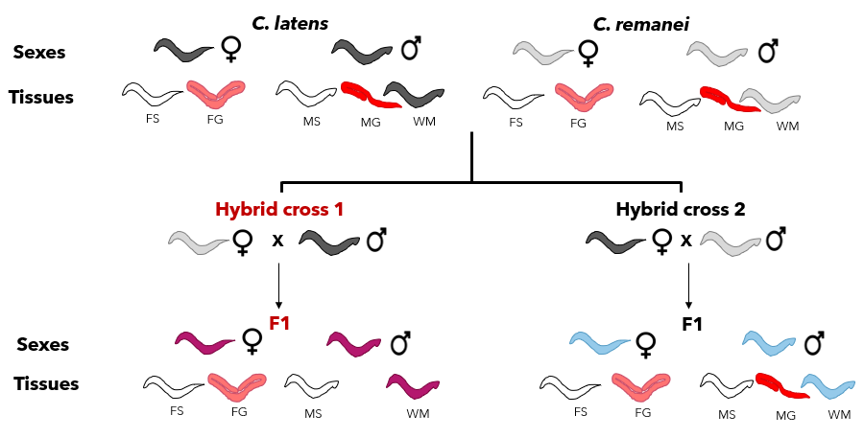
Figure 4. 1:Schematic representation of samples in the final RNASeq dataset. The RNASeq dataset consists of three replicates each with 19 different treatments making a total of 57 samples. This dataset consists of RNA samples from two sexes (males (M) and females (F)) and two tissues from each sex (gonad (G) and somatic tissue (S)), all for two wildtype species, C. latens (black) and C. remanei (grey), as well as the two hybrid types from both direction of the cross (H1 cross (pink) and H2 cross (blue)). The exception to this factorial sampling is the absence of male gonad samples from hybrid cross 1 (H1), due to inability to isolate them reliably. Whole male samples (WM) were also collected for each of the species and hybrid combinations.

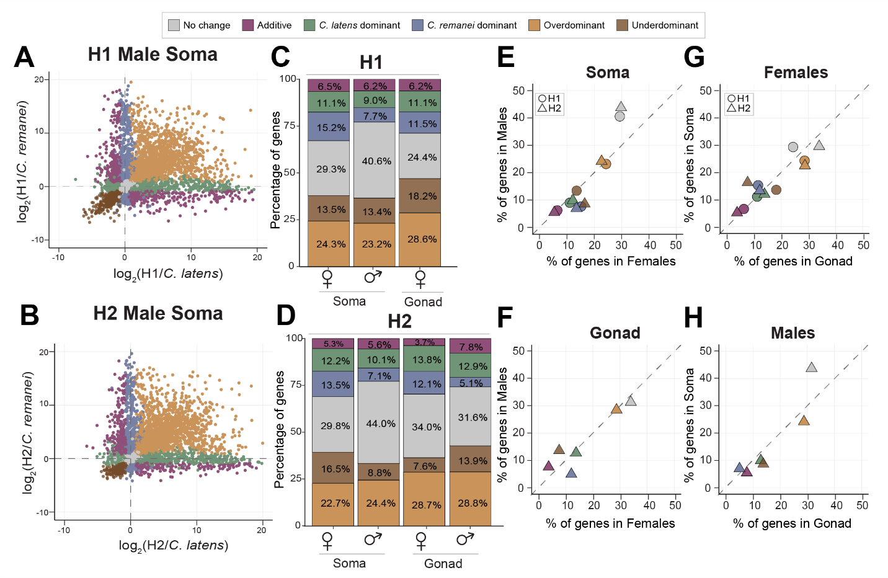
Figure 4. 2: Hybrids reveal extensive transgressive overdominant and underdominant expression in both sexes and for both soma and gonad tissue types. (A, B) Scatterplots visualizing different gene expression inheritance categories based on log fold change in soma sample expression for hybrid males relative to each parental species C. remanei and C. latens. Plots for male gonad expression as well as female gonad and soma expression are shown in Supplementary Figure S4.4. (C, D) Barplots depicting the percentage of genes showing different expression inheritance profiles from each hybrid cross direction for each sex and tissue type. (E, F) Scatterplots that contrast percentage of genes in males (y-axis) and females (x-axis) across soma (E) and gonad (F) identify sex-biased inheritance patterns for inheritance categories that do not lie on the y=x dashed line. (G, H) Scatterplots that contrast difference in abundance of genes between soma (y-axis) and gonad (x-axis) for females (G) and males (H) identify tissue-biased patterns of gene expression inheritance from off-diagonal categories. Both H1 and H2 have male and female somatic tissue samples, but only H2 has male gonad tissue samples. H1 and H2 hybrid crosses are represented by circle and triangle respectively (E, G).

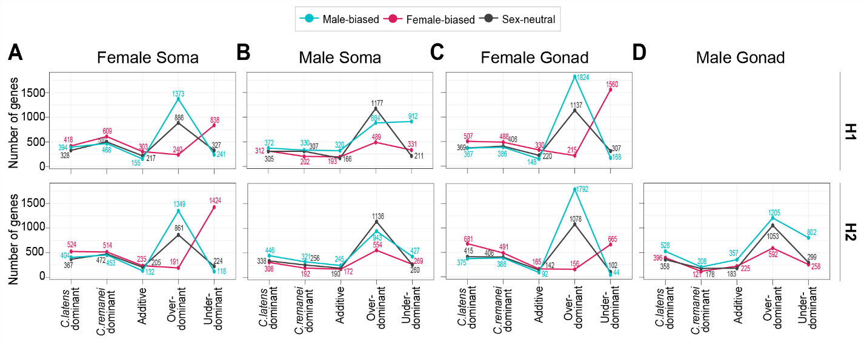
Figure 4. 3: Transgressive expression in hybrids (overdominant and underdominant) consist mostly of genes with sex-biased expression in the parental species. The three lines depict the number of male-biased genes (blue), female-biased genes (pink) and sex-neutral genes (black) observed across inheritance profiles for each sex, tissue type and reciprocal cross. Hybrid females tend to have upregulation of male-biased genes and downregulation of female-biased genes (A, C). Hybrid males show misexpression primarily due to sex-neutral and male-biased genes (B, D). Genes with the ambiguous expression inheritance category are not shown for clarity.

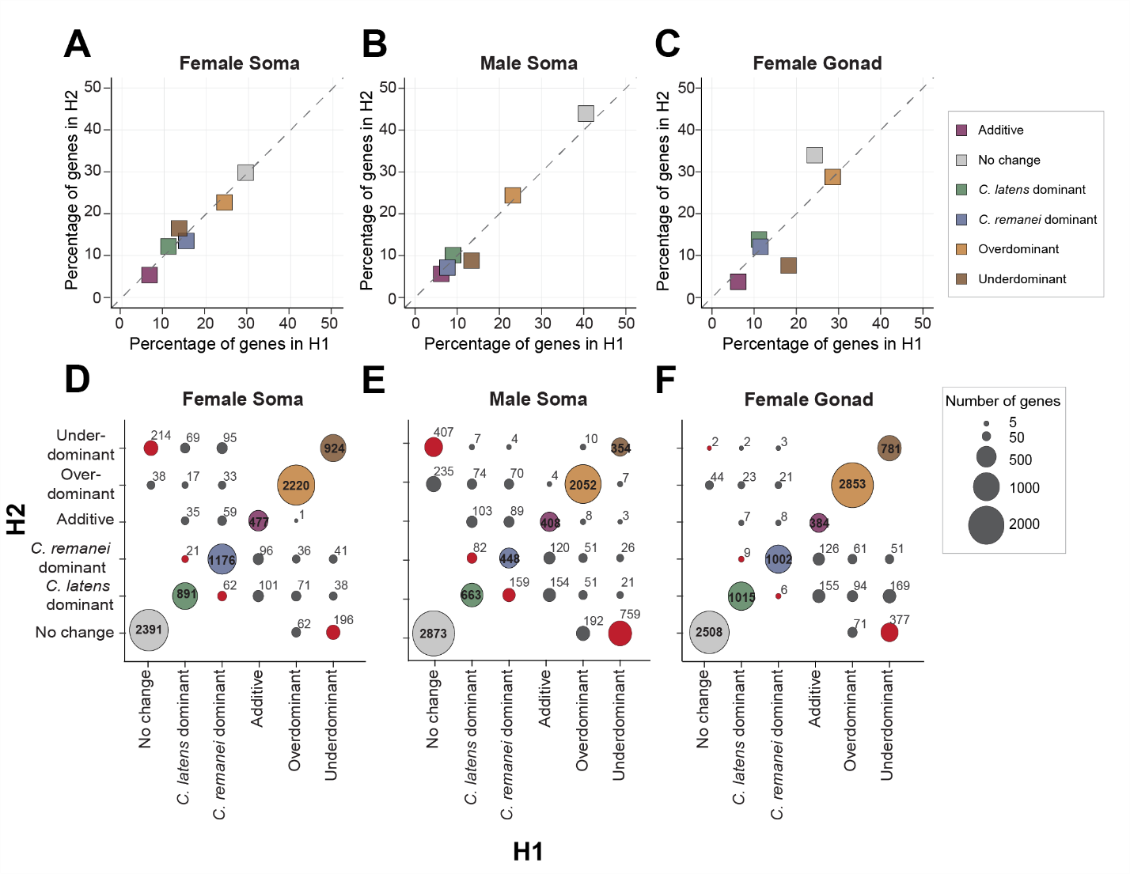
Figure 4. 4: Despite higher overlap in genes across reciprocal crosses, H1 and H2 display distinct patterns for expression inheritance. Scatterplots comparing the proportion of genes in different expression inheritance categories between H1 and H2 in the female soma (A), male soma (B) and female gonad (C). (D, E, F) Bubble plots contrasting the genes in each expression inheritance category across reciprocal crosses with area of the bubble proportional to the number of genes. The bubbles on the diagonal represent the number of genes overlapping between H1 (x-axis) and H2 (y-axis) and red bubbles highlight the number of genes showing underdominant expression exclusively in one hybrid cross. Females show a higher level of overlap in genes than males across reciprocal crosses (D, F, bubbles on the diagonal). Males have higher number of underdominant genes unique to each hybrid cross (E, red bubbles).

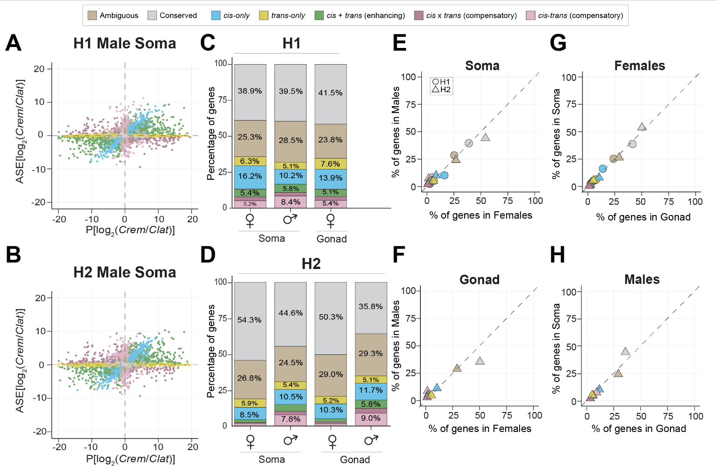
Figure 4. 5: Gene misregulation differs between sexes and reciprocal hybrid crosses. (A, B) Classification of regulatory divergence using allele specific expression analysis. Gene expression between the species C. remanei (Crem) and C. latens (Clat) (x-axis) is compared to the expression difference between alleles within the hybrids (y-axis). Genes with conserved regulation across species are depicted in grey. Such genes show no expression difference between species as well as no difference between alleles within hybrids and fall on the origin (0,0). Scatterplots depicting regulatory divergence for genes expressed in male gonad, female soma and gonad are depicted in Supplementary figure S4.6. (C, D) Barplots depicting the percentage of genes showing different regulatory divergence categories detected in each reciprocal cross H1 (C) and H2 (D) for autosomal genes. More than ~38% of total genes in all samples displayed allele-specific expression profiles consistent with regulatory conservation. H2 males displayed an overall higher number of genes showing regulatory divergence (predominantly cis-only and cis-trans compensatory divergence) than females (n_{MS} = 3341; n_{FS} = 1979; n_{MG} = 3655; n_{FG} = 2184). This pattern also broadly holds true for X-linked genes (Supplementary figure S4.7). (E, F) Scatterplots contrast percentage of genes in males (y-axis) and females (x-axis) across soma (E) and gonad (F) to identify sex-specific regulatory divergence patterns as deviation from the y=x dashed line. (G, H) Scatterplots contrast difference in abundance of genes between soma (y-axis) and gonad (x-axis) for females (G) and males (H) to identify tissue-specific patterns of regulatory divergence. Both H1 and H2 crosses have male and female somatic tissue samples, but only H2 has male gonad tissue samples.

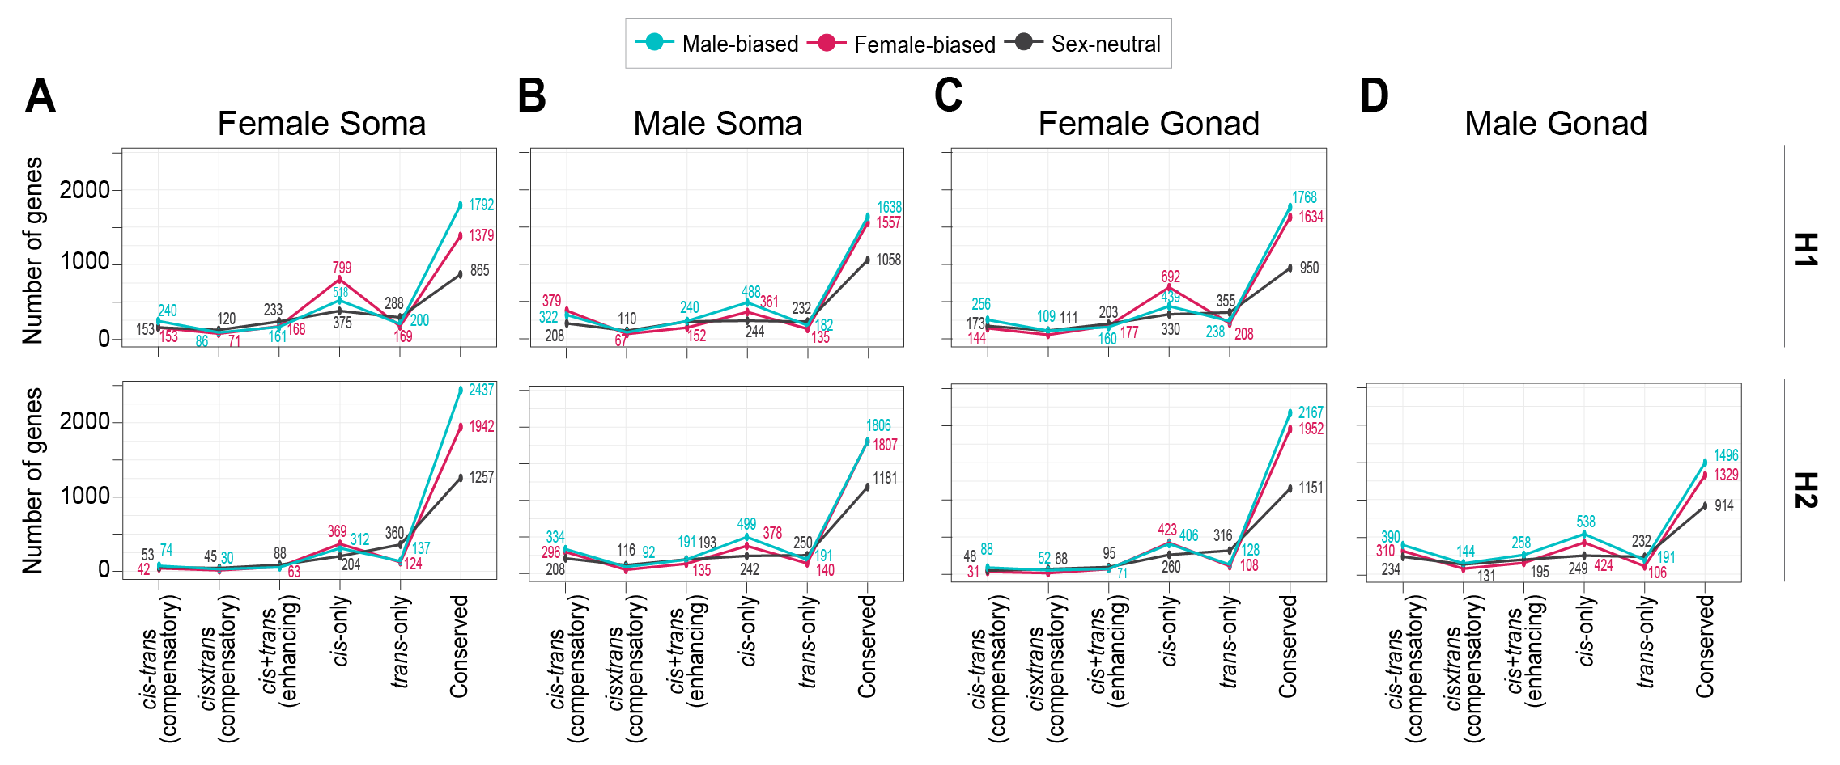
Figure 4. 6: Sex-biased genes display conserved regulation or cis-only regulatory divergence. cis-only divergence disproportionately influences female-biased genes in hybrid females (A, C) and male-biased genes in hybrid males (B, D). In contrast, trans-only divergence tends to affect sex-neutral genes in both sexes. Genes with ambiguous expression categorization not shown for clarity. While this line plot represents autosomal genes, it is important to note that cis-trans compensatory divergence also plays a role in the misexpression of sex-biased genes, particularly in males with respect to X-linked genes (Supplementary figure S4.8).

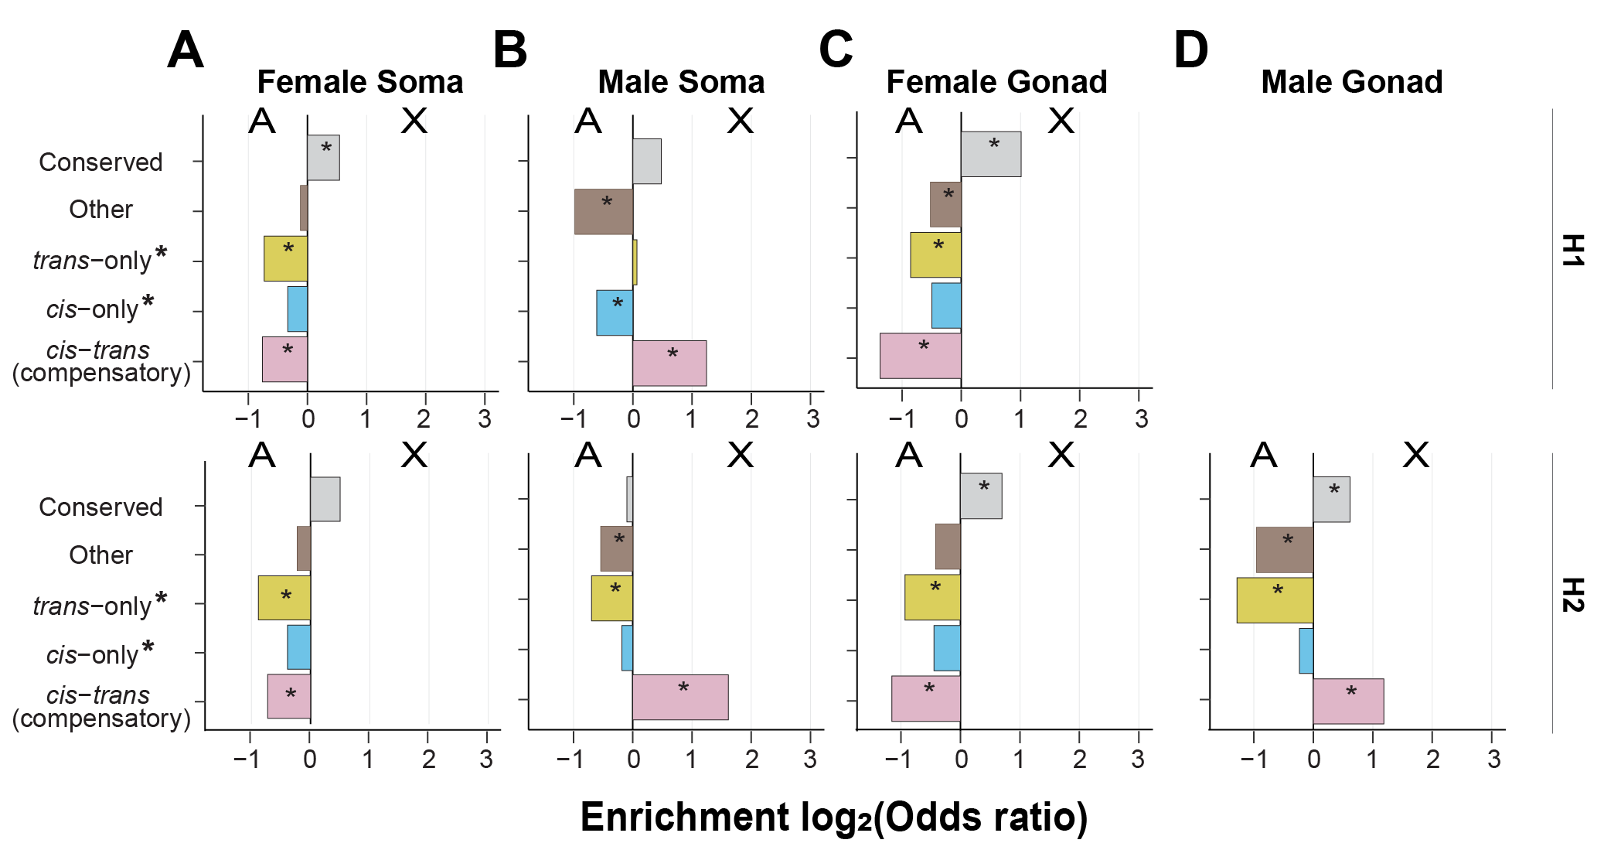
Figure 4. 7: cis-trans compensatory changes are enriched on the male X-chromosome. Enrichment of genes linked to autosomes versus X-chromosomes for different categories of regulatory divergence inferred from soma (A, B) and gonad (C, D) tissue types of females (A, C) and males (B, D) for H1 hybrids (top row) and H2 hybrids (bottom row). H1 hybrids have C. remanei maternal parents; H2 hybrids have C. latens maternal parents. Positive values of the log₂(odds ratio) denote enrichment for the X-chromosome and negative values indicate enrichment for autosomes. The X-chromosome of males exhibited an enrichment of genes displaying cis-trans compensatory regulatory divergence, whereas such genes were underrepresented on the X-chromosomes of females. Regulatory categories defined according to the restricted criteria used for X-chromosomes in males (Supplementary Figure S4.2).

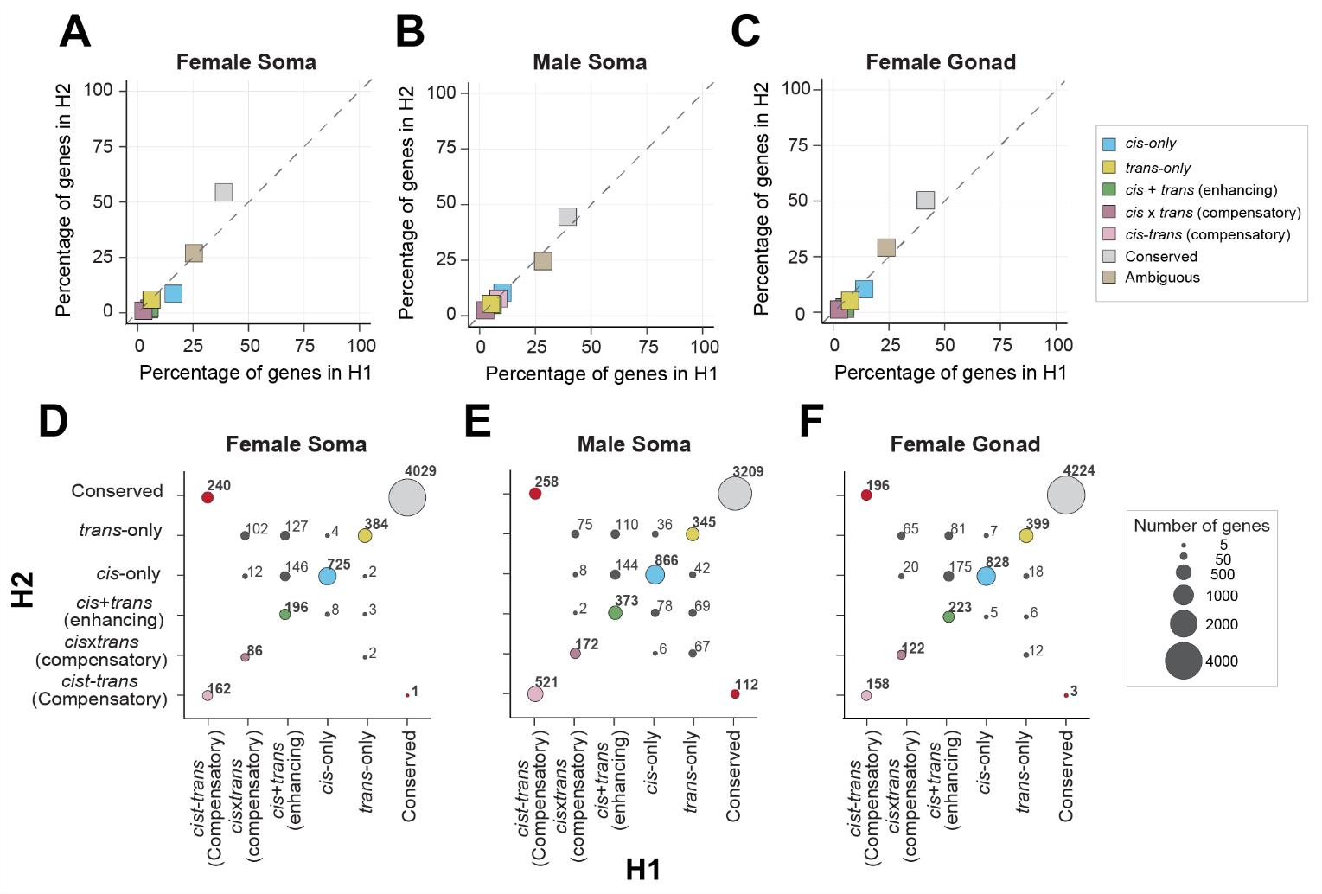
Figure 4. 8: cis-trans compensatory divergence results in unique misregulation patterns between H1 and H2. Scatterplots comparing percentage of genes in different regulatory divergence categories across H1 (x-axis) and H2 (y-axis) for female soma (A), male soma (B) and female gonad (C). Overall, H1 has a higher number of misregulated genes than H2 across all samples. cis-only divergence is more common in females while cis-only and cis-trans compensatory divergence in common in males. (D, E, F) Bubble plots contrasting the genes and their regulatory divergence in H1 (x-axis) and H2 (y-axis) to identify genes unique to each hybrid cross with area of the bubble proportional to the number of genes. The bubbles on the diagonals represent the number of genes overlapping between H1 (x-axis) and H2 (y-axis) and red bubbles highlight the number of genes showing cis-trans compensatory divergence exclusively in one hybrid cross. More than 50% of genes showing cis-trans compensatory regulation in H1 females were conserved in H2 females. Only autosomal genes are represented for clarity as the X-linked genes were classified with a slightly different criteria due to their hemizygous nature in males (see methods; Supplementary Figure S4.2). Both autosomal and X-linked genes display similar patterns for male soma, however, in case of X-linked genes in female soma and gonad, no deviation is observed from the diagonal indicating hybrid-cross specific misregulation predominantly of autosomal genes in females (Supplementary figure S4.9).

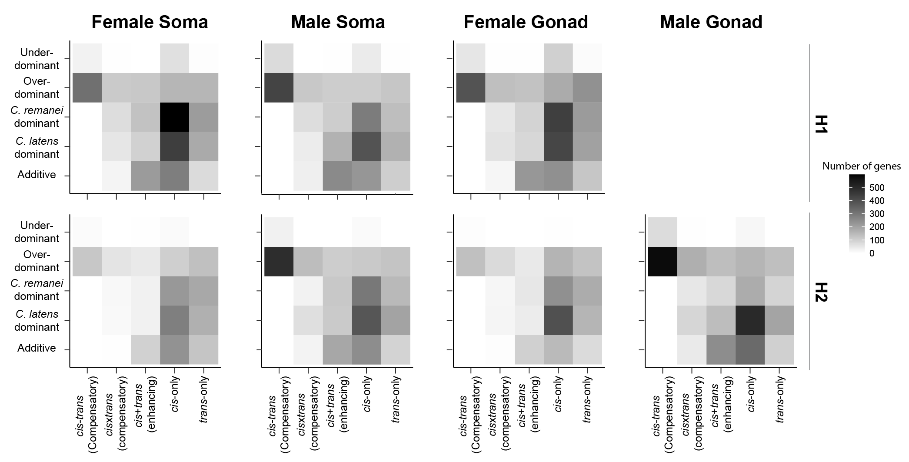
Figure 4. 9: cis- and trans- changes underlie higher proportion of transgressive genes in both sexes. Heatmap with number of genes in different regulatory divergence categories for each expression inheritance profile to identify gene regulatory divergence underlying transgressive expression in autosomes. Males and females show different gene regulatory divergence underlying gene misexpression with higher contributions of cis-trans compensatory divergence to transgressive expression in males. The regulatory divergence for X-linked genes in males was inferred in a different way (see methods) due to the hemizygous nature of the X-chromosome in males (Supplementary Figure S4.2) but display similar pattern as autosomes and are depicted in Supplementary figure S4.10.

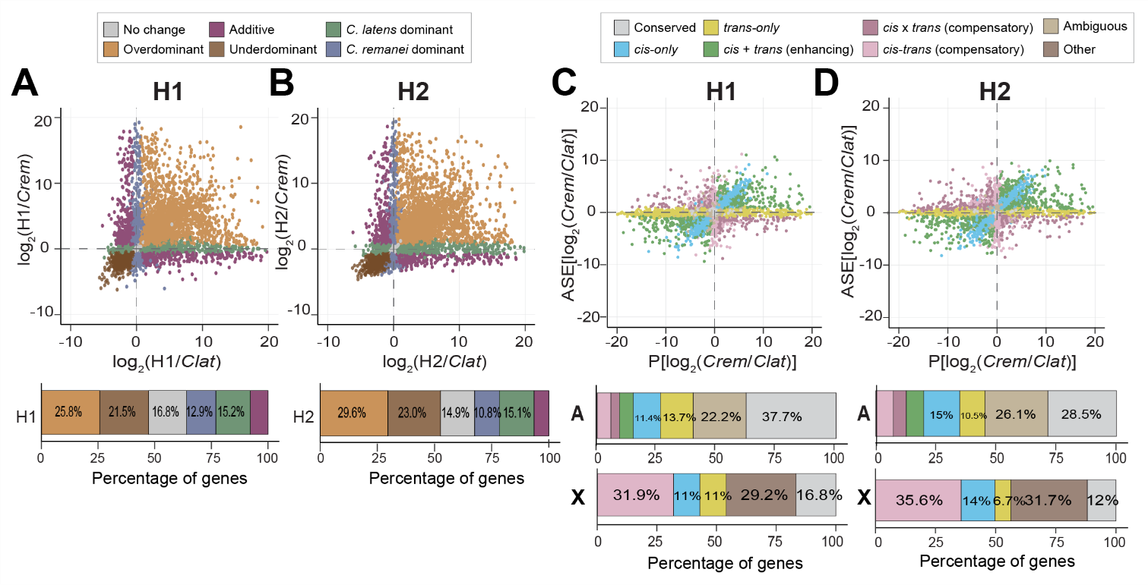
Figure 4. 10: Analyses of whole male samples reveal higher misexpression and misregulation in H2 than H1. Gene expression dominance patterns observed in whole male samples of H1 (A) and H2 (B). (n_{H1, No change} = 1989 or ~17%; n_{H2, No change}=1743 or ~15%; n_{H1, Underdominant} = 2537 or ~21%; n_{H2, Underdominant} = 2689 or ~23%; n_{H1, Clat} = 1794 or ~15%; n_{H2, Clat} = 1768 or ~15%; n_{H1, Cre} = 1521 or ~13%; n_{H2, Cre} = 1264 or ~11%; n_{H1, Additive} = 924 or ~8%; n_{H2, Additive} = 762 or ~6.5%). Regulatory divergence based on allele-specific expression analysis in whole male samples of H1 (C) and H2 (D). Bars underneath the scatterplots represent proportion of genes in different gene expression and regulatory divergence categories for autosomal genes and X-linked genes. X-linked regulatory divergence was classified according to a modified scheme due to the hemizygous nature of X-chromosomes in males. cis-only, trans-only and cis-trans compensatory genes were identified using this approach in males. All other genes showing significant gene expression deviations were classified under the “Other” category (including genes displaying cis x trans (compensatory), cis + trans (enhancing) and ambiguous expression) (See methods, Figure S4.2).

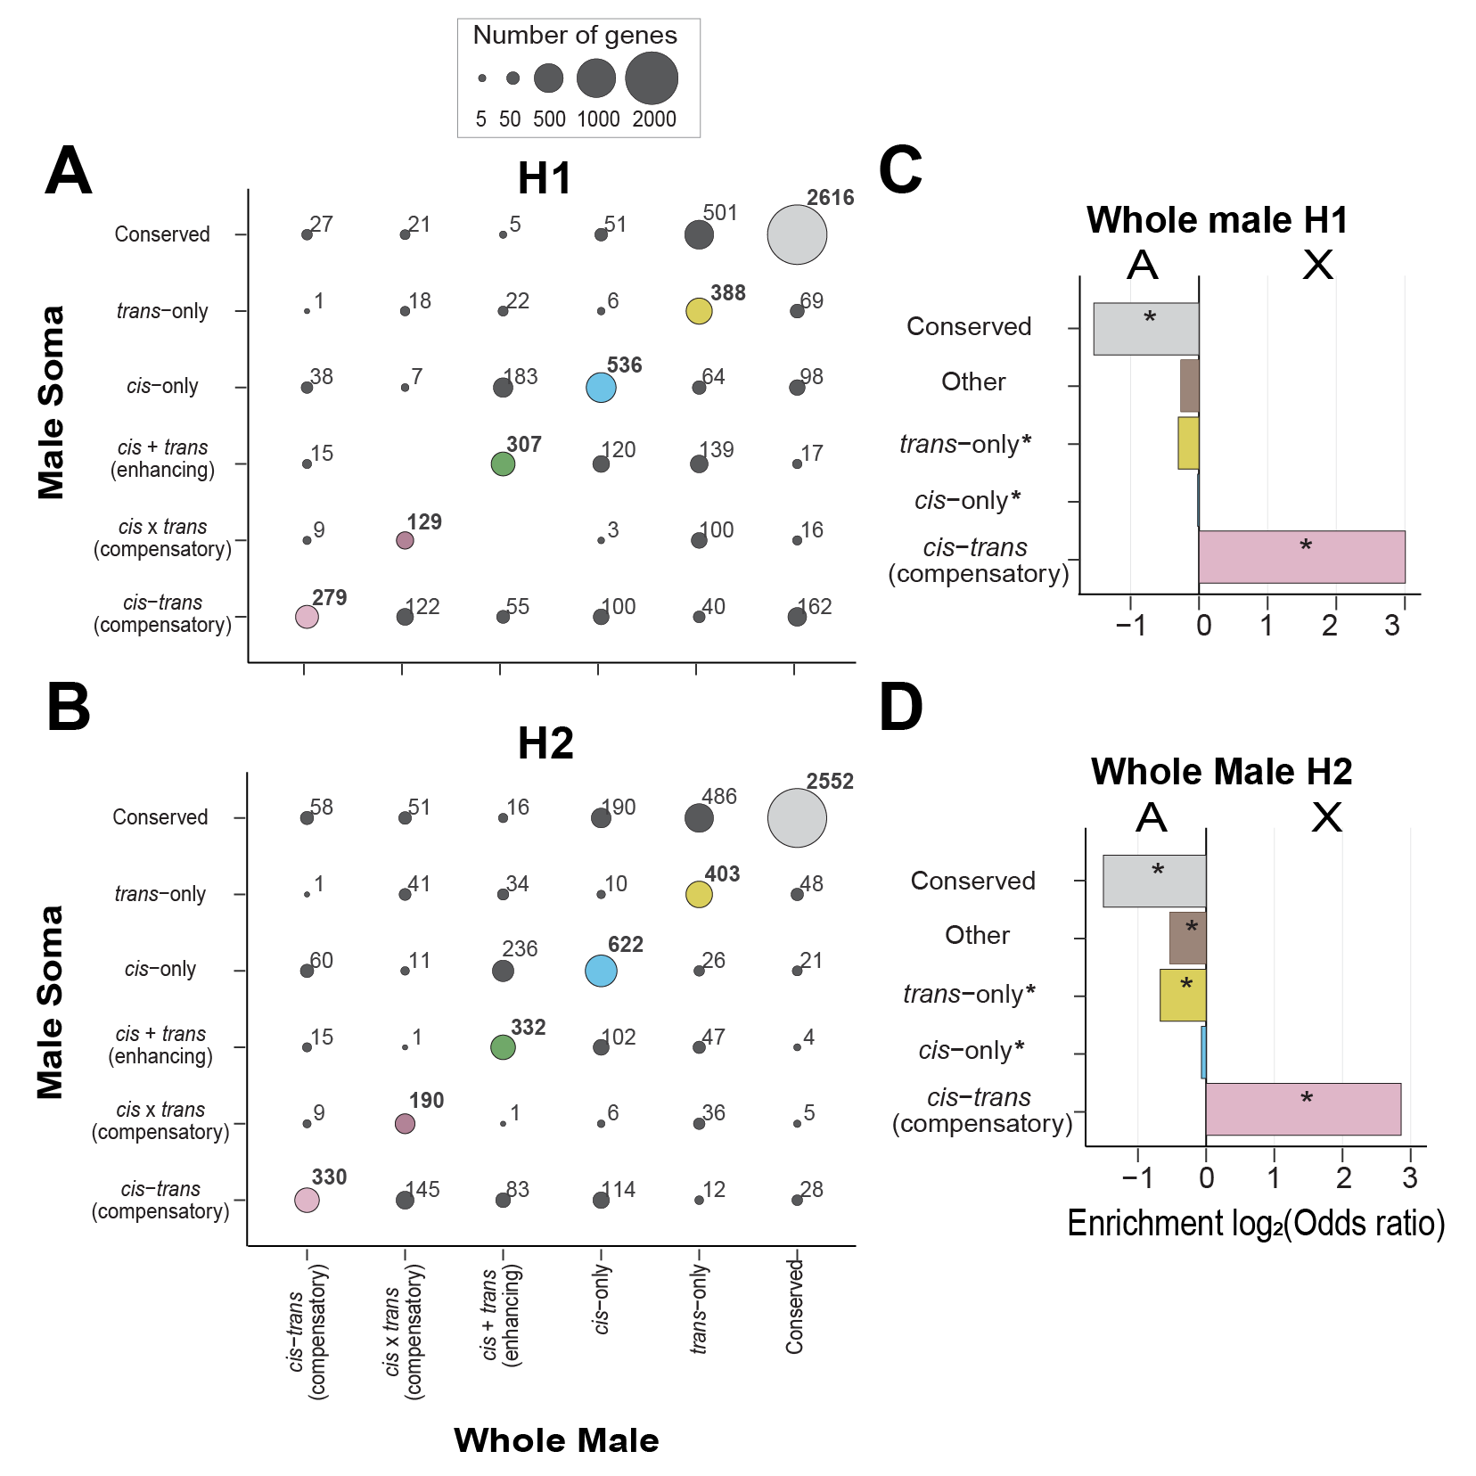
Figure 4. 11: X-chromosome displays an enrichment for cis-trans compensatory divergence in H1 and H2 hybrid cross. (A, B) Comparison of regulatory divergence between male soma (y-axis) and whole male samples (x-axis) in H1 (A) and H2 (B). Bubble area is proportional to the number of genes and bubbles on the diagonals display overlap in the number of genes between H1 and H2. X-linked and ambiguous genes not shown for clarity. Most genes fall on the diagonal except for genes displaying trans-only divergence indicating similarity in regulatory divergence between samples for autosomal genes. However, comparison between whole male samples and male soma for X-linked genes displays substantial sample-specific misregulation (Supplementary figure S4.11). (C, D) Enrichment of genes displaying regulatory divergence between autosomes and X-chromosomes in whole male sample. Positive values represent enrichment on X-chromosome and negative values represent enrichment on autosomes. The X-linked genes in males were categorized based on a slightly different comparison (see methods) (Supplementary Figure S4.2). we categorized genes displaying cisxtrans (compensatory) divergence, cis+trans (compensatory) divergence, and ambiguous expression into the "other" category for direct comparison between X-linked and autosomal genes (see methods).
References
Adams, P. E., Eggers, V. K., Millwood, J. D., Sutton, J. M., Pienaar, J., & Fierst, J. L. (2023). Genome Size Changes by Duplication, Divergence, and Insertion in Caenorhabditis Worms. Molecular Biology and Evolution, 40(3), msad039. https://doi.org/10.1093/molbev/msad039
Alcazar, R. M., Lin, R., & Fire, A. Z. (2008). Transmission dynamics of heritable silencing induced by double-stranded RNA in Caenorhabditis elegans. Genetics, 180(3), 1275–1288. https://doi.org/10.1534/genetics.108.089433
Arico, J. K., Katz, D. J., van der Vlag, J., & Kelly, W. G. (2011). Epigenetic patterns maintained in early Caenorhabditis elegans embryos can be established by gene activity in the parental germ cells. PLoS Genetics, 7(6), e1001391. https://doi.org/10.1371/journal.pgen.1001391
Artieri, C. G., & Fraser, H. B. (2014). Evolution at two levels of gene expression in yeast. Genome Research, 24(3), 411–421. https://doi.org/10.1101/gr.165522.113
Assis, R., Zhou, Q., & Bachtrog, D. (2012). Sex-Biased Transcriptome Evolution in Drosophila. Genome Biology and Evolution, 4(11), 1189–1200. https://doi.org/10.1093/gbe/evs093
Banho, C. A., Mérel, V., Oliveira, T. Y. K., Carareto, C. M. A., & Vieira, C. (2021). Comparative transcriptomics between Drosophila mojavensis and D. arizonae reveals transgressive gene expression and underexpression of spermatogenesis-related genes in hybrid testes. Scientific Reports, 11(1), 9844. https://doi.org/10.1038/s41598-021-89366-2
Bateson, W. (1909). Heredity and Variation in Modern Lights by William Bateson. In: Seward, A.C. Ed., Darwin and Modern Science, Cambridge University Press, Cambridge, 85–101.
Batista, P. J., Ruby, J. G., Claycomb, J. M., Chiang, R., Fahlgren, N., Kasschau, K. D., Chaves, D. A., Gu, W., Vasale, J. J., Duan, S., Conte, D., Luo, S., Schroth, G. P., Carrington, J. C., Bartel, D. P., & Mello, C. C. (2008). PRG-1 and 21U-RNAs interact to form the piRNA complex required for fertility in C. elegans. Molecular Cell, 31(1), 67–78. https://doi.org/10.1016/j.molcel.2008.06.002
Bell, G. D. M., Kane, N. C., Rieseberg, L. H., & Adams, K. L. (2013). RNA-Seq Analysis of Allele-Specific Expression, Hybrid Effects, and Regulatory Divergence in Hybrids Compared with Their Parents from Natural Populations. Genome Biology and Evolution, 5(7), 1309–1323. https://doi.org/10.1093/gbe/evt072
Ben-David, E., Burga, A., & Kruglyak, L. (2017). A maternal-effect selfish genetic element in Caenorhabditis elegans. Science (New York, N.Y.), 356(6342), 1051–1055. https://doi.org/10.1126/science.aan0621
Ben-David, E., Pliota, P., Widen, S. A., Koreshova, A., Lemus-Vergara, T., Verpukhovskiy, P., Mandali, S., Braendle, C., Burga, A., & Kruglyak, L. (2021). Ubiquitous Selfish Toxin-Antidote Elements in Caenorhabditis Species. Current Biology: CB, 31(5), 990-1001.e5. https://doi.org/10.1016/j.cub.2020.12.013
Bi, Y., Ren, X., Li, R., Ding, Q., Xie, D., & Zhao, Z. (2019). Specific Interactions Between Autosome and X Chromosomes Cause Hybrid Male Sterility in Caenorhabditis Species. Genetics, 212(3), 801–813. https://doi.org/10.1534/genetics.119.302202
Billi, A. C., Freeberg, M. A., Day, A. M., Chun, S. Y., Khivansara, V., & Kim, J. K. (2013). A conserved upstream motif orchestrates autonomous, germline-enriched expression of Caenorhabditis elegans piRNAs. PLoS Genetics, 9(3), e1003392. https://doi.org/10.1371/journal.pgen.1003392
Bittorf, B. E. (2018). Mapping Hybrid Lethal Genes on the X Chromosome of C. Briggsae [Wright State University]. https://etd.ohiolink.edu/apexprod/rws_olink/r/1501/10?clear=10&p10_accession_num=wright152770556182685
Blekhman, R., Oshlack, A., Chabot, A. E., Smyth, G. K., & Gilad, Y. (2008). Gene Regulation in Primates Evolves under Tissue-Specific Selection Pressures. PLOS Genetics, 4(11), e1000271. https://doi.org/10.1371/journal.pgen.1000271
Bolger, A. M., Lohse, M., & Usadel, B. (2014). Trimmomatic: A flexible trimmer for Illumina sequence data. Bioinformatics, 30(15), 2114–2120. https://doi.org/10.1093/bioinformatics/btu170
Bomblies, K., Lempe, J., Epple, P., Warthmann, N., Lanz, C., Dangl, J. L., & Weigel, D. (2007). Autoimmune Response as a Mechanism for a Dobzhansky-Muller-Type Incompatibility Syndrome in Plants. PLOS Biology, 5(9), e236. https://doi.org/10.1371/journal.pbio.0050236
Brekke, T. D., Henry, L. A., & Good, J. M. (2016). Genomic imprinting, disrupted placental expression, and speciation. Evolution; International Journal of Organic Evolution, 70(12), 2690–2703. https://doi.org/10.1111/evo.13085
Brekke, T. D., Moore, E. C., Campbell-Staton, S. C., Callahan, C. M., Cheviron, Z. A., & Good, J. M. (2021). X chromosome-dependent disruption of placental regulatory networks in hybrid dwarf hamsters. Genetics, 218(1), iyab043. https://doi.org/10.1093/genetics/iyab043
Buckley, B. A., Burkhart, K. B., Gu, S. G., Spracklin, G., Kershner, A., Fritz, H., Kimble, J., Fire, A., & Kennedy, S. (2012). A nuclear Argonaute promotes multigenerational epigenetic inheritance and germline immortality. Nature, 489(7416), 447–451. https://doi.org/10.1038/nature11352
Bundus, J. D., Wang, D., & Cutter, A. D. (2018). Genetic basis to hybrid inviability is more complex than hybrid male sterility in Caenorhabditis nematodes. Heredity, 121(2), 169–182.
Burga, A., Ben-David, E., & Kruglyak, L. (2020). Toxin-Antidote Elements Across the Tree of Life. Annual Review of Genetics, 54, 387–415. https://doi.org/10.1146/annurev-genet-112618-043659
Burkhart, K. B., Guang, S., Buckley, B. A., Wong, L., Bochner, A. F., & Kennedy, S. (2011). A pre-mRNA-associating factor links endogenous siRNAs to chromatin regulation. PLoS Genetics, 7(8), e1002249. https://doi.org/10.1371/journal.pgen.1002249
Carroll, S. B. (2005). Evolution at Two Levels: On Genes and Form. PLOS Biology, 3(7), e245. https://doi.org/10.1371/journal.pbio.0030245
Catron, D. J., & Noor, M. A. F. (2008). Gene Expression Disruptions of Organism versus Organ in Drosophila Species Hybrids. PLOS ONE, 3(8), e3009. https://doi.org/10.1371/journal.pone.0003009
Civetta, A. (2016). Misregulation of Gene Expression and Sterility in Interspecies Hybrids: Causal Links and Alternative Hypotheses. Journal of Molecular Evolution, 82(4–5), 176–182. https://doi.org/10.1007/s00239-016-9734-z
Conine, C. C., Batista, P. J., Gu, W., Claycomb, J. M., Chaves, D. A., Shirayama, M., & Mello, C. C. (2010). Argonautes ALG-3 and ALG-4 are required for spermatogenesis-specific 26G-RNAs and thermotolerant sperm in Caenorhabditis elegans. Proceedings of the National Academy of Sciences, 107(8), 3588–3593. https://doi.org/10.1073/pnas.0911685107
Coolon, J. D., Stevenson, K. R., McManus, C. J., Yang, B., Graveley, B. R., & Wittkopp, P. J. (2015). Molecular Mechanisms and Evolutionary Processes Contributing to Accelerated Divergence of Gene Expression on the Drosophila X Chromosome. Molecular Biology and Evolution, 32(10), 2605–2615. https://doi.org/10.1093/molbev/msv135
Coughlan, J. M., Wilson Brown, M., & Willis, J. H. (2020). Patterns of Hybrid Seed Inviability in the Mimulus guttatus sp. Complex Reveal a Potential Role of Parental Conflict in Reproductive Isolation. Current Biology, 30(1), 83-93.e5. https://doi.org/10.1016/j.cub.2019.11.023
Cowell, F. (2022). 100 years of Haldane’s rule. Journal of Evolutionary Biology, n/a(n/a). https://doi.org/10.1111/jeb.14112
Coyne, J. A., & Allen Orr, H. (1998). The evolutionary genetics of speciation. Philosophical Transactions of the Royal Society of London. Series B: Biological Sciences, 353(1366), 287–305.
Coyne, J. A., & Orr, H. A. (2004). Speciation (Vol. 37). Sinauer Associates Sunderland, MA.
Cutter, A. D. (2008). Divergence Times in Caenorhabditis and Drosophila Inferred from Direct Estimates of the Neutral Mutation Rate. Molecular Biology and Evolution, 25(4), 778–786. https://doi.org/10.1093/molbev/msn024
Cutter, A. D. (2018). X exceptionalism in Caenorhabditis speciation. Molecular Ecology, 27(19), 3925–3934. https://doi.org/10.1111/mec.14423
Cutter, A. D. (2023a). Sexual conflict, heterochrony and tissue specificity as evolutionary problems of adaptive plasticity in development. Proceedings. Biological Sciences, 290(2008), 20231854. https://doi.org/10.1098/rspb.2023.1854
Cutter, A. D. (2023b). Speciation and development. Evolution & Development, 25(4–5), 289–327. https://doi.org/10.1111/ede.12454
Cutter, A. D., & Bundus, J. D. (2020). Speciation and the developmental alarm clock. eLife, 9, e56276. https://doi.org/10.7554/eLife.56276
Cutter, A. D., Garrett, R. H., Mark, S., Wang, W., & Sun, L. (2019). Molecular evolution across developmental time reveals rapid divergence in early embryogenesis. Evolution Letters, 3(4), 359–373. https://doi.org/10.1002/evl3.122
Cutter, A. D., & Ward, S. (2005). Sexual and Temporal Dynamics of Molecular Evolution in C. elegans Development. Molecular Biology and Evolution, 22(1), 178–188. https://doi.org/10.1093/molbev/msh267
Dall’Acqua, M. N., Peake, A. L., Bielaska Da Silva, J., Issakova, D., & Cutter, A. D. (2025). A constellation of dysfunctional hybrid phenotypes enforces reproductive isolation between Caenorhabditis nematode species. Evolution, qpaf112. https://doi.org/10.1093/evolut/qpaf112
Das, P. P., Bagijn, M. P., Goldstein, L. D., Woolford, J. R., Lehrbach, N. J., Sapetschnig, A., Buhecha, H. R., Gilchrist, M. J., Howe, K. L., Stark, R., Matthews, N., Berezikov, E., Ketting, R. F., Tavaré, S., & Miska, E. A. (2008). Piwi and piRNAs act upstream of an endogenous siRNA pathway to suppress Tc3 transposon mobility in the Caenorhabditis elegans germline. Molecular Cell, 31(1), 79–90. https://doi.org/10.1016/j.molcel.2008.06.003
Davis, A. W. (1993). Evolution of Postmating Reproductive Isolation: The Composite Nature of Haldane’s Rule and Its Genetic Bases. The American Naturalist, 142(2), 187–212. https://doi.org/10.1086/285534
de Zwaan, D. R., Mackenzie, J., Mikkelsen, E., Wood, C., & Wang, S. (2022). Pleiotropic opposing dominance within a color gene block contributes to a nascent species boundary via its influence on hybrid male territorial behavior. PNAS Nexus, 1(3), pgac074. https://doi.org/10.1093/pnasnexus/pgac074
Delph, L. F., & Demuth, J. P. (2016). Haldane’s Rule: Genetic Bases and Their Empirical Support. Journal of Heredity, 107(5), 383–391. https://doi.org/10.1093/jhered/esw026
DeRenzo, C., Reese, K. J., & Seydoux, G. (2003). Exclusion of germ plasm proteins from somatic lineages by cullin-dependent degradation. Nature, 424(6949), 685–689. https://doi.org/10.1038/nature01887
Dey, A., Jeon, Y., Wang, G.-X., & Cutter, A. D. (2012). Global Population Genetic Structure of Caenorhabditis remanei Reveals Incipient Speciation. Genetics, 191(4), 1257–1269. https://doi.org/10.1534/genetics.112.140418
Dey, A., Jin, Q., Chen, Y.-C., & Cutter, A. D. (2014). Gonad morphogenesis defects drive hybrid male sterility in asymmetric hybrid breakdown of Caenorhabditis nematodes: Hybrid male sterility in Caenorhabditis. Evolution & Development, 16(6), 362–372. https://doi.org/10.1111/ede.12097
Dion-Côté, A.-M., Renaut, S., Normandeau, E., & Bernatchez, L. (2014). RNA-seq reveals transcriptomic shock involving transposable elements reactivation in hybrids of young lake whitefish species. Molecular Biology and Evolution, 31(5), 1188–1199. https://doi.org/10.1093/molbev/msu069
Dobin, A., Davis, C. A., Schlesinger, F., Drenkow, J., Zaleski, C., Jha, S., Batut, P., Chaisson, M., & Gingeras, T. R. (2013). STAR: Ultrafast universal RNA-seq aligner. Bioinformatics, 29(1), 15–21.
Ellegren, H., & Parsch, J. (2007). The evolution of sex-biased genes and sex-biased gene expression. Nature Reviews Genetics, 8(9), Article 9. https://doi.org/10.1038/nrg2167
Ellison, C. K., Niehuis, O., & Gadau, J. (2008). Hybrid breakdown and mitochondrial dysfunction in hybrids of Nasonia parasitoid wasps. Journal of Evolutionary Biology, 21(6), 1844–1851. https://doi.org/10.1111/j.1420-9101.2008.01608.x
Erwin, A. A., Galdos, M. A., Wickersheim, M. L., Harrison, C. C., Marr, K. D., Colicchio, J. M., & Blumenstiel, J. P. (2015). piRNAs Are Associated with Diverse Transgenerational Effects on Gene and Transposon Expression in a Hybrid Dysgenic Syndrome of D. virilis. PLoS Genetics, 11(8), e1005332. https://doi.org/10.1371/journal.pgen.1005332
Félix, M.-A., Braendle, C., & Cutter, A. D. (2014). A Streamlined System for Species Diagnosis in Caenorhabditis (Nematoda: Rhabditidae) with Name Designations for 15 Distinct Biological Species. PLOS ONE, 9(4), e94723. https://doi.org/10.1371/journal.pone.0094723
Fierst, J. L., Willis, J. H., Thomas, C. G., Wang, W., Reynolds, R. M., Ahearne, T. E., Cutter, A. D., & Phillips, P. C. (2015). Reproductive Mode and the Evolution of Genome Size and Structure in Caenorhabditis Nematodes. PLOS Genetics, 11(6), e1005323. https://doi.org/10.1371/journal.pgen.1005323
Fitch, D. H. A. (2005). Introduction to nematode evolution and ecology. In WormBook: The Online Review of C. elegans Biology [Internet]. WormBook. https://www.ncbi.nlm.nih.gov/books/NBK19688/
Gilad, Y., Oshlack, A., & Rifkin, S. A. (2006). Natural selection on gene expression. Trends in Genetics, 22(8), 456–461. https://doi.org/10.1016/j.tig.2006.06.002
Gomes, S., & Civetta, A. (2014). Misregulation of spermatogenesis genes in Drosophila hybrids is lineage-specific and driven by the combined effects of sterility and fast male regulatory divergence. Journal of Evolutionary Biology, 27(9), 1775–1783. https://doi.org/10.1111/jeb.12428
Gomes, S., & Civetta, A. (2015). Hybrid male sterility and genome-wide misexpression of male reproductive proteases. Scientific Reports, 5(1), 11976. https://doi.org/10.1038/srep11976
Goncalves, A., Leigh-Brown, S., Thybert, D., Stefflova, K., Turro, E., Flicek, P., Brazma, A., Odom, D. T., & Marioni, J. C. (2012). Extensive compensatory cis-trans regulation in the evolution of mouse gene expression. Genome Research, 22(12), 2376–2384.
Good, J. M., Giger, T., Dean, M. D., & Nachman, M. W. (2010). Widespread Over-Expression of the X Chromosome in Sterile F1 Hybrid Mice. PLoS Genetics, 6(9), e1001148. https://doi.org/10.1371/journal.pgen.1001148
Grath, S., & Parsch, J. (2016). Sex-Biased Gene Expression. Annual Review of Genetics, 50(1), 29–44. https://doi.org/10.1146/annurev-genet-120215-035429
Guerrero, R. F., Posto, A. L., Moyle, L. C., & Hahn, M. W. (2016). Genome-wide patterns of regulatory divergence revealed by introgression lines: BRIEF COMMUNICATION. Evolution, 70(3), 696–706. https://doi.org/10.1111/evo.12875
Haerty, W., & Singh, R. S. (2006). Gene Regulation Divergence Is a Major Contributor to the Evolution of Dobzhansky–Muller Incompatibilities between Species of Drosophila. Molecular Biology and Evolution, 23(9), 1707–1714. https://doi.org/10.1093/molbev/msl033
Haldane, J. B. (1922). Sex ratio and unisexual sterility in hybrid animals. Journal of Genetics, 12(2), 101–109.
Harrison, P. W., Wright, A. E., Zimmer, F., Dean, R., Montgomery, S. H., Pointer, M. A., & Mank, J. E. (2015). Sexual selection drives evolution and rapid turnover of male gene expression. Proceedings of the National Academy of Sciences, 112(14), 4393–4398. https://doi.org/10.1073/pnas.1501339112
Hill, M. S., Vande Zande, P., & Wittkopp, P. J. (2021). Molecular and evolutionary processes generating variation in gene expression. Nature Reviews Genetics, 22(4), 203–215. https://doi.org/10.1038/s41576-020-00304-w
Hodgins-Davis, A., Rice, D. P., & Townsend, J. P. (2015). Gene expression evolves under a house-of-cards model of stabilizing selection. Molecular Biology and Evolution, 32(8), 2130–2140.
Josefsson, C., Dilkes, B., & Comai, L. (2006). Parent-dependent loss of gene silencing during interspecies hybridization. Current Biology: CB, 16(13), 1322–1328. https://doi.org/10.1016/j.cub.2006.05.045
Kelly, W. G. (2014). Transgenerational epigenetics in the germline cycle of Caenorhabditis elegans. Epigenetics & Chromatin, 7(1), 6. https://doi.org/10.1186/1756-8935-7-6
Kiontke, K., & Fitch, D. H. A. (2005). The phylogenetic relationships of Caenorhabditis and other rhabditids. In WormBook: The Online Review of C. elegans Biology [Internet]. WormBook. https://www.ncbi.nlm.nih.gov/books/NBK19714/
Kirkbride, R. C., Yu, H. H., Nah, G., Zhang, C., Shi, X., & Chen, Z. J. (2015). An Epigenetic Role for Disrupted Paternal Gene Expression in Postzygotic Seed Abortion in Arabidopsis Interspecific Hybrids. Molecular Plant, 8(12), 1766–1775. https://doi.org/10.1016/j.molp.2015.09.009
Landry, C. R., Wittkopp, P. J., Taubes, C. H., Ranz, J. M., Clark, A. G., & Hartl, D. L. (2005). Compensatory cis-trans Evolution and the Dysregulation of Gene Expression in Interspecific Hybrids of Drosophila. Genetics, 171(4), 1813–1822. https://doi.org/10.1534/genetics.105.047449
Larson, E. L., Keeble, S., Vanderpool, D., Dean, M. D., & Good, J. M. (2017). The Composite Regulatory Basis of the Large X-Effect in Mouse Speciation. Molecular Biology and Evolution, 34(2), 282–295. https://doi.org/10.1093/molbev/msw243
Li, R., Ren, X., Bi, Y., Ho, V. W. S., Hsieh, C.-L., Young, A., Zhang, Z., Lin, T., Zhao, Y., Miao, L., Sarkies, P., & Zhao, Z. (2016). Specific down-regulation of spermatogenesis genes targeted by 22G RNAs in hybrid sterile males associated with an X-Chromosome introgression. Genome Research, 26(9), 1219–1232. https://doi.org/10.1101/gr.204479.116
Li, X. C., & Fay, J. C. (2017). Cis-regulatory divergence in gene expression between two thermally divergent yeast species. Genome Biology and Evolution, 9(5), 1120–1129.
Luteijn, M. J., van Bergeijk, P., Kaaij, L. J. T., Almeida, M. V., Roovers, E. F., Berezikov, E., & Ketting, R. F. (2012). Extremely stable Piwi-induced gene silencing in Caenorhabditis elegans. The EMBO Journal, 31(16), 3422–3430. https://doi.org/10.1038/emboj.2012.213
Mack, K. L., Campbell, P., & Nachman, M. W. (2016). Gene regulation and speciation in house mice. Genome Research, 26(4), 451–461. https://doi.org/10.1101/gr.195743.115
Mack, K. L., & Nachman, M. W. (2017). Gene Regulation and Speciation. Trends in Genetics, 33(1), 68–80. https://doi.org/10.1016/j.tig.2016.11.003
Maheshwari, S., & Barbash, D. A. (2011). The Genetics of Hybrid Incompatibilities. Annual Review of Genetics, 45(1), 331–355. https://doi.org/10.1146/annurev-genet-110410-132514
Malone, J. H., & Michalak, P. (2008a). Gene expression analysis of the ovary of hybrid females of Xenopus laevis and X. muelleri. BMC Evolutionary Biology, 8, 82. https://doi.org/10.1186/1471-2148-8-82
Malone, J. H., & Michalak, P. (2008b). Physiological sex predicts hybrid sterility regardless of genotype. Science (New York, N.Y.), 319(5859), 59. https://doi.org/10.1126/science.1148231
Mao, H., Zhu, C., Zong, D., Weng, C., Yang, X., Huang, H., Liu, D., Feng, X., & Guang, S. (2015). The Nrde Pathway Mediates Small-RNA-Directed Histone H3 Lysine 27 Trimethylation in Caenorhabditis elegans. Current Biology: CB, 25(18), 2398–2403. https://doi.org/10.1016/j.cub.2015.07.051
Matute, D. R., & Coyne, J. A. (2010). Intrinsic reproductive isolation between two sister species of Drosophila. Evolution; International Journal of Organic Evolution, 64(4), 903–920. https://doi.org/10.1111/j.1558-5646.2009.00879.x
McManus, C. J., Coolon, J. D., Duff, M. O., Eipper-Mains, J., Graveley, B. R., & Wittkopp, P. J. (2010). Regulatory divergence in Drosophila revealed by mRNA-seq. Genome Research, 20(6), 816–825. https://doi.org/10.1101/gr.102491.109
Meiklejohn, C. D., Coolon, J. D., Hartl, D. L., & Wittkopp, P. J. (2014). The roles of cis- and trans-regulation in the evolution of regulatory incompatibilities and sexually dimorphic gene expression. Genome Research, 24(1), 84–95. https://doi.org/10.1101/gr.156414.113
Meiklejohn, C. D., Parsch, J., Ranz, J. M., & Hartl, D. L. (2003). Rapid evolution of male-biased gene expression in Drosophila. Proceedings of the National Academy of Sciences, 100(17), 9894–9899. https://doi.org/10.1073/pnas.1630690100
Metzger, B. P. H., Wittkopp, P. J., & Coolon, Joseph. D. (2017). Evolutionary Dynamics of Regulatory Changes Underlying Gene Expression Divergence among Saccharomyces Species. Genome Biology and Evolution, 9(4), 843–854. https://doi.org/10.1093/gbe/evx035
Meyer, B. J. (2022). The X chromosome in C. elegans sex determination and dosage compensation. Current Opinion in Genetics & Development, 74, 101912. https://doi.org/10.1016/j.gde.2022.101912
Michalak, P., & Malone, J. H. (2008). Testis-derived microRNA profiles of African clawed frogs (Xenopus) and their sterile hybrids. Genomics, 91(2), 158–164. https://doi.org/10.1016/j.ygeno.2007.10.013
Michalak, P., & Noor, M. A. F. (2004). Association of Misexpression with Sterility in Hybrids of Drosophila simulansand D. mauritiana. Journal of Molecular Evolution, 59(2), 277–282. https://doi.org/10.1007/s00239-004-2622-y
Moehring, A. J., Llopart, A., Elwyn, S., Coyne, J. A., & Mackay, T. F. C. (2006). The Genetic Basis of Postzygotic Reproductive Isolation Between Drosophila santomea and D. yakuba Due to Hybrid Male Sterility. Genetics, 173(1), 225–233. https://doi.org/10.1534/genetics.105.052985
Montgomery, S. H., & Mank, J. E. (2016). Inferring regulatory change from gene expression: The confounding effects of tissue scaling. Molecular Ecology, 25(20), 5114–5128. https://doi.org/10.1111/mec.13824
Mushegian, A. R., Garey, J. R., Martin, J., & Liu, L. X. (1998). Large-Scale Taxonomic Profiling of Eukaryotic Model Organisms: A Comparison of Orthologous Proteins Encoded by the Human, Fly, Nematode, and Yeast Genomes. Genome Research, 8(6), 590–598. https://doi.org/10.1101/gr.8.6.590
Orr, H. A. (1996). Dobzhansky, Bateson, and the genetics of speciation. Genetics, 144(4), 1331.
Parisi, M., Nuttall, R., Edwards, P., Minor, J., Naiman, D., Lü, J., Doctolero, M., Vainer, M., Chan, C., Malley, J., Eastman, S., & Oliver, B. (2004). A survey of ovary-, testis-, and soma-biased gene expression in Drosophila melanogaster adults. Genome Biology, 18.
Perry, J. C., Harrison, P. W., & Mank, J. E. (2014). The ontogeny and evolution of sex-biased gene expression in Drosophila melanogaster. Molecular Biology and Evolution, 31(5), 1206–1219. https://doi.org/10.1093/molbev/msu072
Presgraves, D. C. (2010). The molecular evolutionary basis of species formation. Nature Reviews Genetics, 11(3), Article 3. https://doi.org/10.1038/nrg2718
Presgraves, D. C., & Meiklejohn, C. D. (2021). Hybrid Sterility, Genetic Conflict and Complex Speciation: Lessons From the Drosophila simulans Clade Species. Frontiers in Genetics, 12. https://www.frontiersin.org/articles/10.3389/fgene.2021.669045
Price, P. D., Palmer Droguett, D. H., Taylor, J. A., Kim, D. W., Place, E. S., Rogers, T. F., Mank, J. E., Cooney, C. R., & Wright, A. E. (2022). Detecting signatures of selection on gene expression. Nature Ecology & Evolution, 6(7), Article 7. https://doi.org/10.1038/s41559-022-01761-8
Ranz, J. M., Castillo-Davis, C. I., Meiklejohn, C. D., & Hartl, D. L. (2003). Sex-Dependent Gene Expression and Evolution of the Drosophila Transcriptome. Science, 300(5626), 1742–1745. https://doi.org/10.1126/science.1085881
Ranz, J. M., Namgyal, K., Gibson, G., & Hartl, D. L. (2004). Anomalies in the Expression Profile of Interspecific Hybrids of Drosophila melanogaster and Drosophila simulans. Genome Research, 14(3), 373–379. https://doi.org/10.1101/gr.2019804
Rechtsteiner, A., Ercan, S., Takasaki, T., Phippen, T. M., Egelhofer, T. A., Wang, W., Kimura, H., Lieb, J. D., & Strome, S. (2010). The Histone H3K36 Methyltransferase MES-4 Acts Epigenetically to Transmit the Memory of Germline Gene Expression to Progeny. PLoS Genetics, 6(9), e1001091. https://doi.org/10.1371/journal.pgen.1001091
Rice, A. M., & McQuillan, M. A. (2018). Maladaptive learning and memory in hybrids as a reproductive isolating barrier. Proceedings of the Royal Society B: Biological Sciences, 285(1879), 20180542. https://doi.org/10.1098/rspb.2018.0542
Riddle, D. L., Blumenthal, T., Meyer, B. J., & Priess, J. R. (1997). Phylogenetic Context for C. elegans. In C. elegans II. 2nd edition. Cold Spring Harbor Laboratory Press. https://www.ncbi.nlm.nih.gov/books/NBK20148/
Rošić, S., Amouroux, R., Requena, C. E., Gomes, A., Emperle, M., Beltran, T., Rane, J. K., Linnett, S., Selkirk, M. E., Schiffer, P. H., Bancroft, A. J., Grencis, R. K., Jeltsch, A., Hajkova, P., & Sarkies, P. (2018). Evolutionary analysis indicates that DNA alkylation damage is a byproduct of cytosine DNA methyltransferase activity. Nature Genetics, 50(3), 452–459. https://doi.org/10.1038/s41588-018-0061-8
Ross, J. A., Koboldt, D. C., Staisch, J. E., Chamberlin, H. M., Gupta, B. P., Miller, R. D., Baird, S. E., & Haag, E. S. (2011). Caenorhabditis briggsae recombinant inbred line genotypes reveal inter-strain incompatibility and the evolution of recombination. PLoS Genetics, 7(7), e1002174.
Runemark, A., Moore, E. C., & Larson, E. L. (2024). Hybridization and gene expression: Beyond differentially expressed genes. Molecular Ecology, n/a(n/a), e17303. https://doi.org/10.1111/mec.17303
Samson, M., Jow, M. M., Wong, C. C. L., Fitzpatrick, C., Aslanian, A., Saucedo, I., Estrada, R., Ito, T., Park, S. R., Yates, J. R., & Chu, D. S. (2014). The specification and global reprogramming of histone epigenetic marks during gamete formation and early embryo development in C. elegans. PLoS Genetics, 10(10), e1004588. https://doi.org/10.1371/journal.pgen.1004588
Sánchez-Ramírez, S., & Cutter, A. D. (2021). CompMap: An allele-specific expression read-counter based on competitive mapping (p. 2021.02.12.431019). bioRxiv. https://doi.org/10.1101/2021.02.12.431019
Sánchez-Ramírez, S., Weiss, J. G., Thomas, C. G., & Cutter, A. D. (2021). Widespread misregulation of inter-species hybrid transcriptomes due to sex-specific and sex-chromosome regulatory evolution. PLOS Genetics, 17(3), e1009409. https://doi.org/10.1371/journal.pgen.1009409
Schiffman, J. S., & Ralph, P. L. (2022). System drift and speciation. Evolution, 76(2), 236–251.
Schluter, D., & Rieseberg, L. H. (2022). Three problems in the genetics of speciation by selection. Proceedings of the National Academy of Sciences of the United States of America, 119(30), e2122153119. https://doi.org/10.1073/pnas.2122153119
Schwartz-Orbach, L., Zhang, C., Sidoli, S., Amin, R., Kaur, D., Zhebrun, A., Ni, J., & Gu, S. G. (2020). Caenorhabditis elegans nuclear RNAi factor SET-32 deposits the transgenerational histone modification, H3K23me3. eLife, 9, e54309. https://doi.org/10.7554/eLife.54309
Seidel, H. S., Ailion, M., Li, J., van Oudenaarden, A., Rockman, M. V., & Kruglyak, L. (2011). A novel sperm-delivered toxin causes late-stage embryo lethality and transmission ratio distortion in C. elegans. PLoS Biology, 9(7), e1001115. https://doi.org/10.1371/journal.pbio.1001115
Seidel, H. S., Rockman, M. V., & Kruglyak, L. (2008). Widespread genetic incompatibility in C. elegans maintained by balancing selection. Science (New York, N.Y.), 319(5863), 589–594. https://doi.org/10.1126/science.1151107
Seroussi, U., Lugowski, A., Wadi, L., Lao, R. X., Willis, A. R., Zhao, W., Sundby, A. E., Charlesworth, A. G., Reinke, A. W., & Claycomb, J. M. (2023). A comprehensive survey of C. elegans argonaute proteins reveals organism-wide gene regulatory networks and functions. eLife, 12, e83853. https://doi.org/10.7554/eLife.83853
Serrato-Capuchina, A., & Matute, D. R. (2018). The Role of Transposable Elements in Speciation. Genes, 9(5), 254. https://doi.org/10.3390/genes9050254
Servedio, M. R., & Boughman, J. W. (2017). The Role of Sexual Selection in Local Adaptation and Speciation. Annual Review of Ecology, Evolution, and Systematics, 48(1), 85–109. https://doi.org/10.1146/annurev-ecolsys-110316-022905
Servedio, M. R., & Bürger, R. (2014). The counterintuitive role of sexual selection in species maintenance and speciation. Proceedings of the National Academy of Sciences, 111(22), 8113–8118. https://doi.org/10.1073/pnas.1316484111
Shen, S. Q., Turro, E., & Corbo, J. C. (2014). Hybrid mice reveal parent-of-origin and Cis- and trans-regulatory effects in the retina. PloS One, 9(10), e109382. https://doi.org/10.1371/journal.pone.0109382
Shi, X., Ng, D. W.-K., Zhang, C., Comai, L., Ye, W., & Jeffrey Chen, Z. (2012). Cis- and trans-regulatory divergence between progenitor species determines gene-expression novelty in Arabidopsis allopolyploids. Nature Communications, 3(1), 950. https://doi.org/10.1038/ncomms1954
Shirayama, M., Seth, M., Lee, H.-C., Gu, W., Ishidate, T., Conte, D., & Mello, C. C. (2012). piRNAs initiate an epigenetic memory of nonself RNA in the C. elegans germline. Cell, 150(1), 65–77. https://doi.org/10.1016/j.cell.2012.06.015
Signor, S. A., & Nuzhdin, S. V. (2018). The Evolution of Gene Expression in cis and trans. Trends in Genetics, 34(7), 532–544. https://doi.org/10.1016/j.tig.2018.03.007
Small, C. M., Carney, G. E., Mo, Q., Vannucci, M., & Jones, A. G. (2009). A microarray analysis of sex- and gonad-biased gene expression in the zebrafish: Evidence for masculinization of the transcriptome. BMC Genomics, 10(1), 579. https://doi.org/10.1186/1471-2164-10-579
Spike, C. A., & Strome, S. (2003). Germ plasm: Protein degradation in the soma. Current Biology: CB, 13(21), R837-839. https://doi.org/10.1016/j.cub.2003.10.016
Stern, D. L., & Orgogozo, V. (2009). Is Genetic Evolution Predictable? Science (New York, N.Y.), 323(5915), 746–751. https://doi.org/10.1126/science.1158997
Strome, S. (2005). Specification of the germ line. WormBook: The Online Review of C. Elegans Biology, 1–10. https://doi.org/10.1895/wormbook.1.9.1
Sundararajan, V., & Civetta, A. (2011). Male Sex Interspecies Divergence and Down Regulation of Expression of Spermatogenesis Genes in Drosophila Sterile Hybrids. Journal of Molecular Evolution, 72(1), 80–89. https://doi.org/10.1007/s00239-010-9404-5
Tabuchi, T. M., Rechtsteiner, A., Jeffers, T. E., Egelhofer, T. A., Murphy, C. T., & Strome, S. (2018). Caenorhabditis elegans sperm carry a histone-based epigenetic memory of both spermatogenesis and oogenesis. Nature Communications, 9(1), 4310. https://doi.org/10.1038/s41467-018-06236-8
Teterina, A. A., Willis, J. H., & Phillips, P. C. (2020). Chromosome-Level Assembly of the Caenorhabditis remanei Genome Reveals Conserved Patterns of Nematode Genome Organization. Genetics, 214(4), 769–780. https://doi.org/10.1534/genetics.119.303018
True, J. R., & Haag, E. S. (2001). Developmental system drift and flexibility in evolutionary trajectories. Evolution & Development, 3(2), 109–119.
Turelli, M. (1998). The Causes of Haldane’s Rule. Science, 282(5390), 889–891. https://doi.org/10.1126/science.282.5390.889
Turelli, M., & Moyle, L. C. (2007). Asymmetric postmating isolation: Darwin’s corollary to Haldane’s rule. Genetics, 176(2), 1059–1088. https://doi.org/10.1534/genetics.106.065979
Turissini, D. A., Comeault, A. A., Liu, G., Lee, Y. C. G., & Matute, D. R. (2017). The ability of Drosophila hybrids to locate food declines with parental divergence. Evolution; International Journal of Organic Evolution, 71(4), 960–973. https://doi.org/10.1111/evo.13180
Tyc, K. M., Nabih, A., Wu, M. Z., Wedeles, C. J., Sobotka, J. A., & Claycomb, J. M. (2017). The Conserved Intron Binding Protein EMB-4 Plays Differential Roles in Germline Small RNA Pathways of C. elegans. Developmental Cell, 42(3), 256-270.e6. https://doi.org/10.1016/j.devcel.2017.07.003
Velazco-Cruz, L., & Ross, J. A. (2022). Genetic architecture and temporal analysis of Caenorhabditis briggsae hybrid developmental delay. PLOS ONE, 17(8), e0272843. https://doi.org/10.1371/journal.pone.0272843
Viswanath, A., & Cutter, A. D. (2023). Regulatory Divergence as a Mechanism for X-Autosome Incompatibilities in Caenorhabditis Nematodes. Genome Biology and Evolution, 15(4), evad055. https://doi.org/10.1093/gbe/evad055
Viswanath, A., Fusca, D. D., Calarco, J. A., & Cutter, A. D. (2025). Conserved Gene Expression Plasticity in Development Is More Pervasive Than Expression Divergence Between Species of Caenorhabditis Nematodes. Evolution & Development, 27(4), e70018. https://doi.org/10.1111/ede.70018
Weiser, N. E., & Kim, J. K. (2019). Multigenerational Regulation of the Caenorhabditis elegans Chromatin Landscape by Germline Small RNAs. Annual Review of Genetics, 53(Volume 53, 2019), 289–311. https://doi.org/10.1146/annurev-genet-112618-043505
Wittkopp, P. J., Haerum, B. K., & Clark, A. G. (2004). Evolutionary changes in cis and trans gene regulation. Nature, 430(6995), 85–88. https://doi.org/10.1038/nature02698
Wittkopp, P. J., Haerum, B. K., & Clark, A. G. (2008). Regulatory changes underlying expression differences within and between Drosophila species. Nature Genetics, 40(3), 346–350. https://doi.org/10.1038/ng.77
Wittkopp, P. J., & Kalay, G. (2012). Cis-regulatory elements: Molecular mechanisms and evolutionary processes underlying divergence. Nature Reviews Genetics, 13(1), 59–69. https://doi.org/10.1038/nrg3095
Wray, G. A. (2007). The evolutionary significance of cis-regulatory mutations. Nature Reviews Genetics, 8(3), Article 3. https://doi.org/10.1038/nrg2063
Wray, G. A., Hahn, M. W., Abouheif, E., Balhoff, J. P., Pizer, M., Rockman, M. V., & Romano, L. A. (2003). The Evolution of Transcriptional Regulation in Eukaryotes. Molecular Biology and Evolution, 20(9), 1377–1419. https://doi.org/10.1093/molbev/msg140
Yin, D., Schwarz, E. M., Thomas, C. G., Felde, R. L., Korf, I. F., Cutter, A. D., Schartner, C. M., Ralston, E. J., Meyer, B. J., & Haag, E. S. (2018). Rapid genome shrinkage in a self-fertile nematode reveals sperm competition proteins. Science, 359(6371), 55–61.

